|  |
| --- |
| **PT. BERLIAN SISTEM INFORMASI** |
| **Operating Lease – Collection Process** |
| **USER MANUAL GUIDE** |
|  |
| **Revision 2.0** |
| **3/26/2018** |

|  |
| --- |
| All material contained in this manual including text, graphics, icons and images contain proprietary and confidential information of PT. Berlian Sistem Informasi and are protected by international intellectual property and other laws. The compilation of all text, graphics, icons and images in this Manual is the exclusive property of PT. Berlian Sistem Informasi. No modification, rental, lease, sale, transmission, distribution, reposting or creation or derivate works based on the material in this Manual is allowed, unless with the express permission of PT. Berlian Sistem Informasi. |

# REVISION HISTORY

|  |  |  |  |
| --- | --- | --- | --- |
| Date | Revision | Description | Author |
| 3/28/2016 | 0.0 | Initial Document | Sabilla Pravita Larassati |
| 5/28/2016 | 1.0 | 1st Baseline | Grand Zah Putra |
| 3/26/2018 | 1.1 | Revision 1.1  Add content in page 28 & 29 regarding synchronization MFAPPL  Delete content 1.5.1 and 1.5.2  Update Screen Number page 26 – 49 | Raymond |
| 4/18/2018 | 2.0 | 2nd Baseline | Diarna Roosy |

# TABLE OF CONTENT

REVISION HISTORY 2

TABLE OF CONTENT 3

COLLECTION MODULE 4

1. Monitor Billing Schedule 4

1.1 Edit Billing and Payment History Inquiry 11

1.2 Create Invoice 14

1.3 Create Promise to Pay 17

1.4 Billing and Payment Invoice Approval Path 18

1.4.1 Delivery Invoice Document 21

1.4.2 Invoice Approval 22

1.4.3 Print Invoice Form 23

1.4.4 Print List of Invoice Report 25

1.5 View Billing and Payment History Inquiry 26

1.6 Create RAL 28

2. Monitor Billing Overdue 30

2.1 Create Reminder Memo 32

2.2 Create Warning Letter 33

2.3 Edit Warning Letter 35

2.4 Warning Letter Approval 37

2.5 Print Warning Letter Form 38

2.6 Warning Letter History 40

2.7 Print Warning Letter Report 41

2.8 Edit RAL 43

2.9 RAL Approval 45

2.10 Print RAL Form 46

2.11 RAL History 47

2.12 Print RAL Report 48

2.13 Print Billing (schedule/overdue) History 50

# COLLECTION MODULE

Operating Lease Support System consist of Procurement Process, Collection Process, Maintenance Process, and Collection Process. All features will be described in the subsequent sections. The Collection menu of Operating Lease Support System serves as the continuation of Unit Management process, and Maintenance Process. With the Collection menu, you will be able to monitor and edit billing payment, create invoice and monitor invoice progress, input payment history on monthly base, manage RAL, and manage warning letter.

Additionally you can enter new record, make changes, and inspect a detail record, and also filter specific records based on columns by writing a keyword on the search field. The features and data contained in your Operating Lease Support System menu are limited by your security and data authorization settings so you may not be able to access all features.

Only authorized user have access to all records in order to keep them up to date. Collection modules provides following functions:

1. Monitor billing payment schedule before due date.
2. Monitor billing payment after due date.
3. Filter and sort a data that appears on the list. To do this function user can do as follows:

* Click  to sort a record ascending or descending.
* Filter a numbers of records by selecting.
* Filter records by input keywords at.

# Monitor Billing Schedule

Screen of **Monitor Billing Schedule** will be used by PIC collection to monitor payment billing on monthly base. After BAST DSF to customer has been conducted, billing will automatically generate and displayed in **Monitor Billing Schedule** screen. Using this feature, user can monitor billing schedule, edit billing, create invoice, and send reminder mail to customer. Monitor will be based on end of period usage unit date (monthly date) and due date.

At the beginning, user can open **Monitor Billing Schedule** Screen by clicking the “**Monitor Schedule**” on the **Collection** menu. Once clicked the menu, system will display the **Monitor Billing** page. When opening the page it may look as following:

1. Navigate to Collection menu and click “**Monitor Schedule**”.

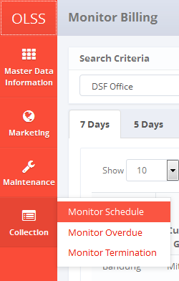

Screen 1: Collection Menu – Monitor Schedule

1. System will show **Monitor Billing** screen that consisted of agreement that approaching due date or agreement that already reach end contract. The main page of **Monitor Billing** is shown below:

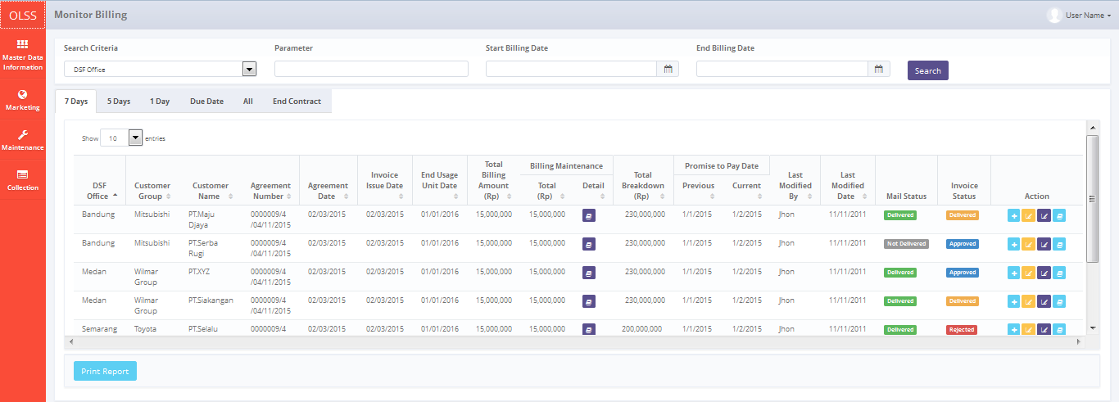

Screen 2: Monitor Billing Schedule Screen

On **Monitor Billing** screen, there are 6 tabs in total, which are:

* 1. Tab 7 days, display agreement number with status “Open” that has remaining 7 days before end usage unit date.
  2. Tab 5 days, display agreement number with status “Open” that has remaining 5 days before due date.
  3. Tab 1 day, display agreement number with status “Open” that has remaining 1 day before due date.
  4. Tab Due date, display agreement number with status “Open” that already reach due date.
  5. Tab all; display all agreement number with status “Open”.
  6. Tab End contract, display agreement on last month billing payment to end contract.

Each tab gives different function. There are 7 buttons that will be displayed on tab 7 days, which are:



Screen 3: Monitor Billing Screen – Tab 7 Days

* 1. Maintenance Billing Detail: view maintenance amount and information for each unit leased in monthly basis. Only enabled if agreement maintenance type is CSD. Below is the maintenance billing detail screen:

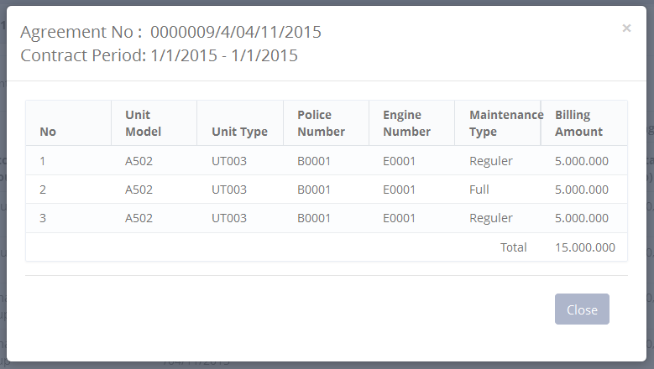

Screen 4: Maintenance Billing Detail Pop up Screen

* 1. Create Invoice: create new invoice and receipt on selected agreement.
  2. Edit Billing and Payment History: edit billing of payment history inquiry.
  3. Input Promise to Pay: input date of promise date.
  4. Billing and Payment History Approval Path: display list of invoice information.
  5. : Print list of billing payment based on specific search.

Tab 5 days and 1 day have different buttons than tab 7 days, the buttons are:

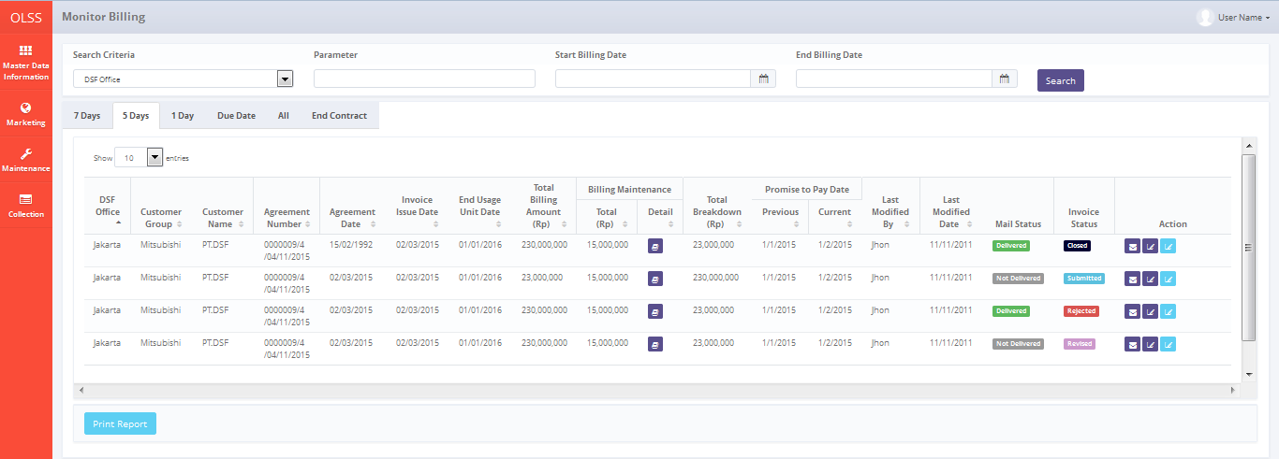

Screen 5: Monitor Billing Schedule – Tab 5 Days

1. Maintenance Billing Detail: view maintenance amount on billing period. Only enabled if agreement maintenance type is CSD.
2. Send reminder email: click to send reminder before due date. Notification will show upon successful sending. Below is the success notification after the email is successfully sent:



Screen 6: Reminder Email Success Notification

1. Input Promise to Pay: input date of promise date.
2. View Billing & Payment History Inquiry: view billing payment information, can navigate to **Edit Billing** screen**,** and Add Partial Payment screen.
3. : Print list of billing report based on specific search.

On Tab due date, there are 3 buttons which are:

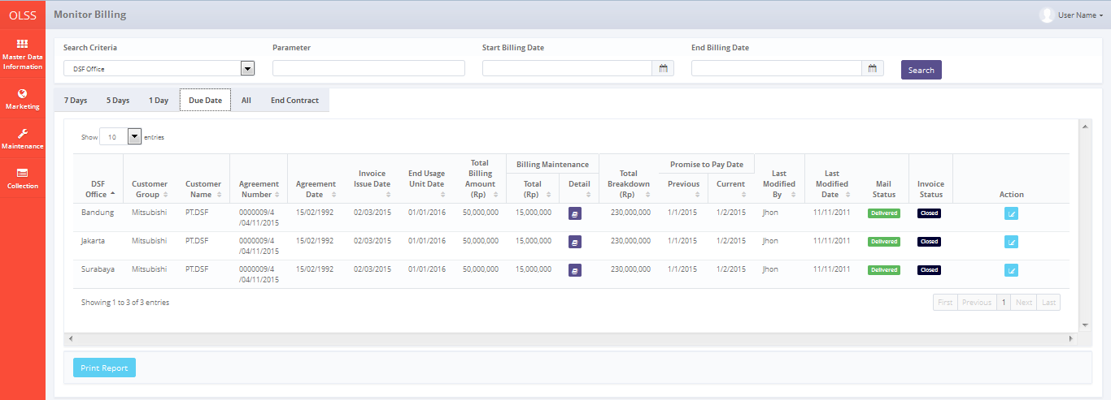

Screen 7: Monitor Billing Schedule Screen – Tab Due Date

* 1. Maintenance billing detail: view maintenance on billing period. Only enabled if agreement maintenance type is CSD.
  2. Edit billing and payment history inquiry: modify billing payment information.
  3. : Print list of agreement based on specific search.

On Tab all, there are 5 buttons which are:

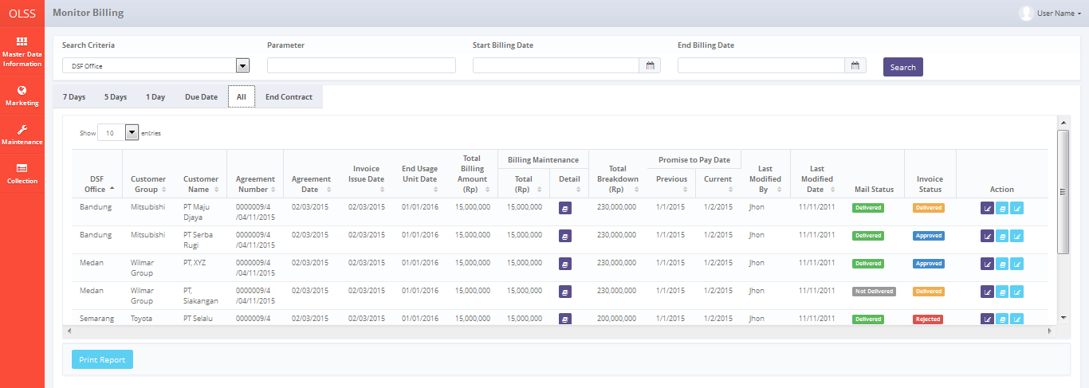

Screen 8: Monitor Billing Schedule – Tab All

1. Maintenance billing detail: view maintenance on billing period. Only enabled if agreement maintenance type is CSD.
2. Promise to pay: input payment date.
3. Billing and Payment Invoice Approval Path: display list of invoice.
4. Edit Billing and payment history inquiry: modify billing payment information.
5. : Print list of agreement based on specific search.

On Tab end contract, there are 3 buttons which are:

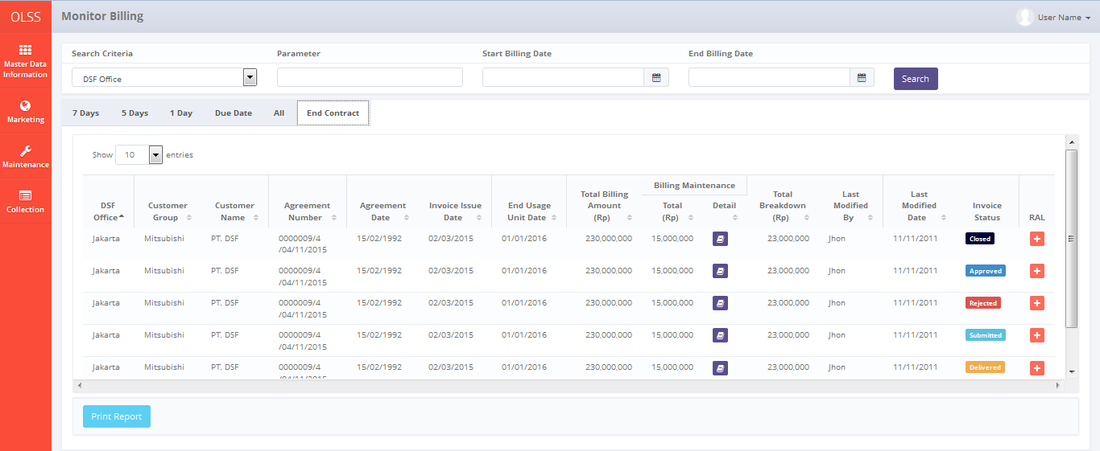

Screen 9: Monitor Billing Schedule Screen – Tab End Contract

1. Maintenance billing detail: view maintenance on billing period. Only enabled if agreement maintenance type is CSD.
2. Create RAL: Create Return Authorization Letter for customer.
3. : Print list of agreement based on specific search.

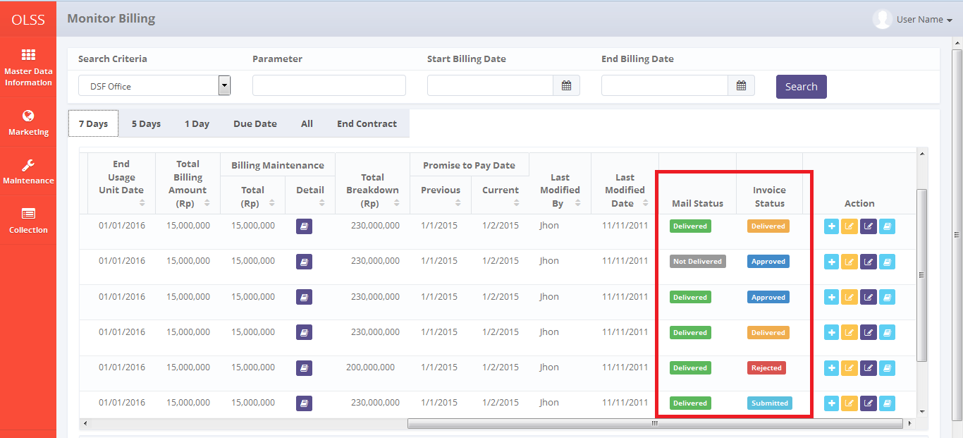

Screen 10: Monitor Billing Schedule Screen – Status

On the right view of **Monitor Billing Schedule** screen, there are two columns with status in it; the first column is **Mail Status** and the second one is **Invoice Status**. **Mail status** has two statuses which are:

1. , means the reminder email has been sent to customer email.
2. , means the reminder email hasn’t been sent to customer email.

While Invoice Status has 5 statuses which are:

1. , means the invoice has been submitted by PIC collection. Need to be checked by DSF authorized user.
2. , means the invoice has been approved by DSF authorized user.
3. , means the invoice has been rejected by DSF authorized user.
4. , means the invoice hardcopy has been delivered to customer.
5. Closed, means the invoice has been paid by customer.

## Edit Billing and Payment History Inquiry

Before user create invoice to customer, user can edit the billing in case there is additional payment to be included. To edit billing and payment, there is more than one way. First, navigate to **Monitor Billing Schedule** screen – Tab 7 days / Tab 5 days / Tab 1 day, or navigate to **View Billing and Payment History Inquiry**. After that, click **Edit Billing** button. Both processes can be seen below:

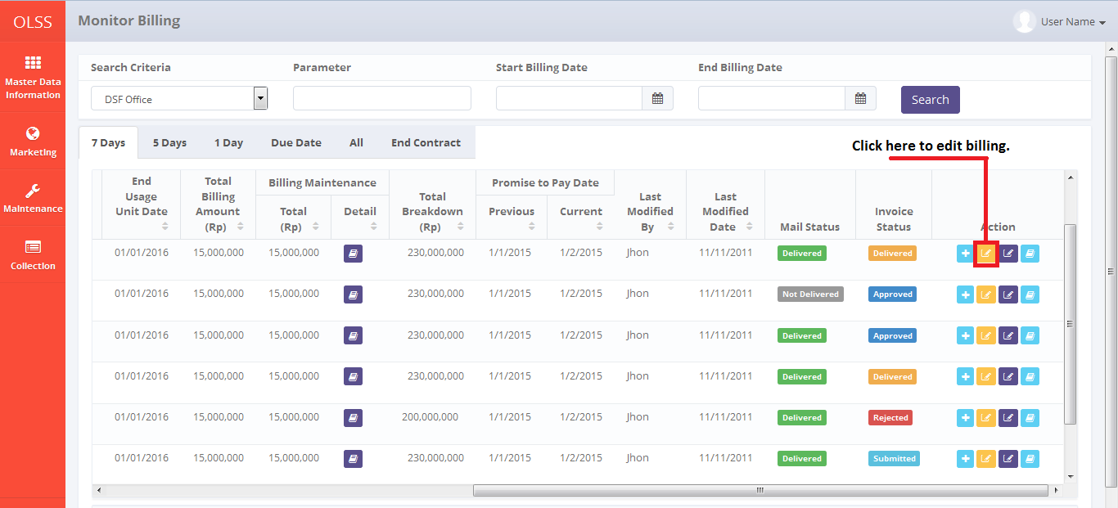

Screen 11: Alternative to edit billing via Monitor Billing Schedule Screen

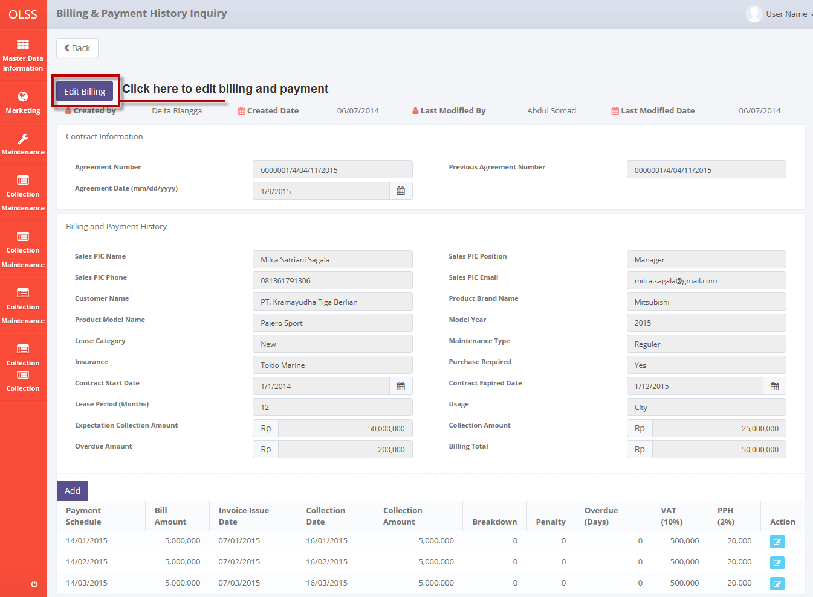

Screen 12: Alternative to edit billing via Billing and Payment History Inquiry Screen

System will display **Edit Billing and Payment History Inquiry** screen.

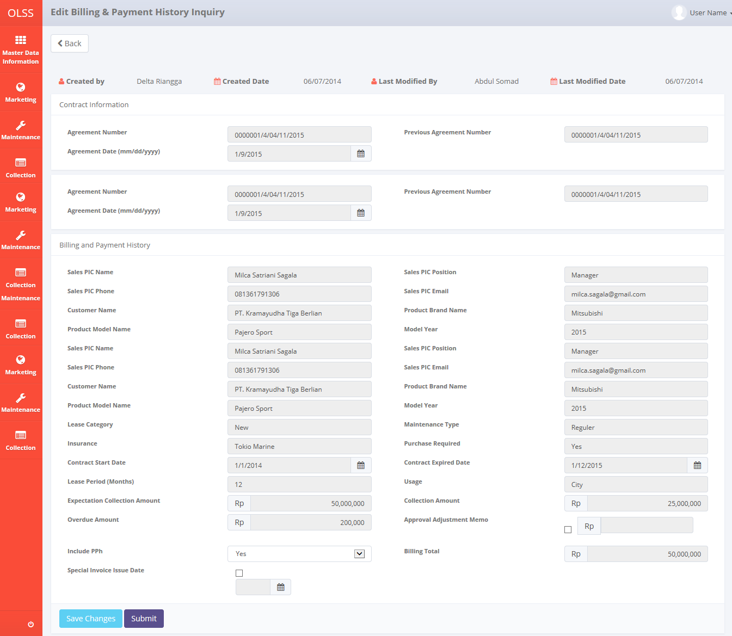

Screen 13: Edit Billing and Payment History Inquiry Screen

There are two buttons that will be displayed on the screen as follows:

1. , to go back to previous screen; Monitor Billing Schedule.
2. , to update billing and payment.

There are information fields on top of the screen, consist of the user information that created the document and had make changes to the records. In here user can view contract information, customer information, lease category, maintenance type, and collection amount. If the agreement use breakdown, user can check **approval adjustment memo**, then **breakdown adjustment amount** textbox will active. If customer requests to pay the billing on specific date, user can check **special invoice issue date**, and then date of **issue date** will be active and required.

If data already changed on the screen, user can save data on the system by clicking **Save Changes** button. After clicking **Save Changes**, confirmation pop-up dialog will show up. Click yes to save document.

**Screenshot**

System will notified if it success or failed to save changes.



Screen 14: Edit Billing and Payment Success Notification

## Create Invoice

Invoice can be created once the agreement has reached 7 days before due date or special case agreement where customer request to pay on specific date. If user wants to create Invoice receipt, please follow procedures shown below:

1. Navigate to Monitor Billing Schedule screen - tab 7 days.
2. On 7 days tab, click Create Invoice button. Only agreement with 7 days before end of usage unit or with special condition for invoice date can be created invoice and receipt. System will display Create Invoice screen.

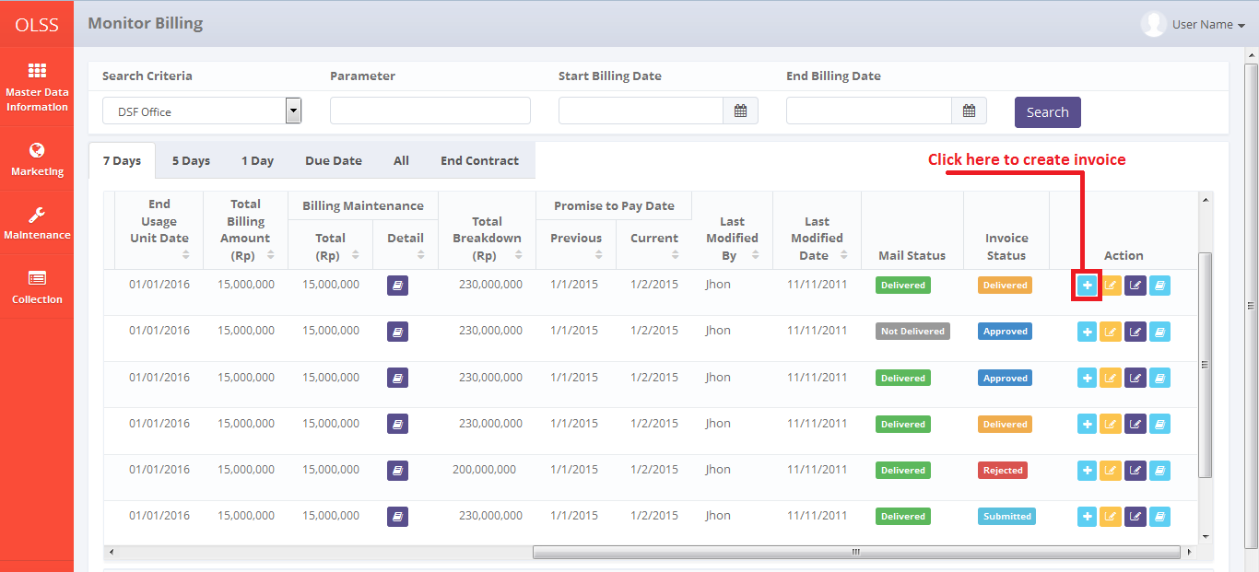

Screen 15: Monitor Billing Schedule Screen – Create Invoice button

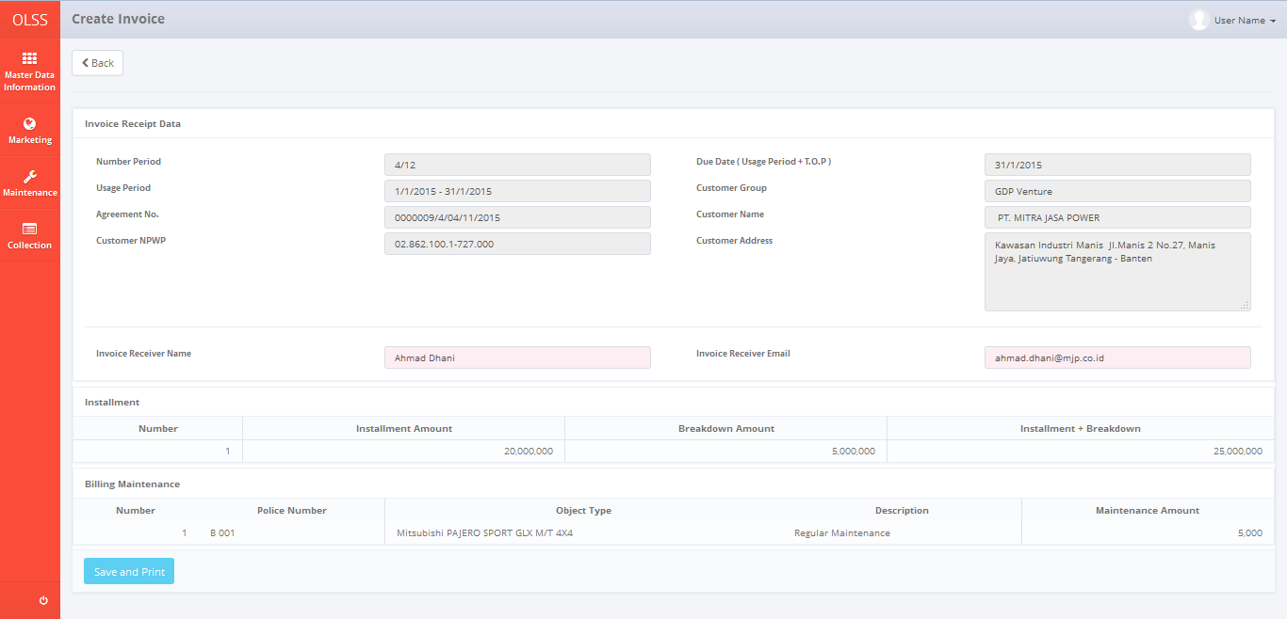

Screen 16: Create Invoice Screen

Once Create Invoice screen opened, there are 2 buttons displayed:

1. : click the button to go to previous screen which is Monitor Billing Schedule.
2. : click the button to save document and print invoice receipt.

To start creating Invoice, please input following fields with necessary information:

* 1. Invoice Receipt Date
* Number period: automatically show month payment/period. Example: 4/12 = 4 refer to invoice for fourth month, and 12 refer to agreement period.
* Usage period: automatically show calendar days 1 – 30/31 monthly.
* Agreement no: automatically show agreement number.
* Customer NPWP: automatically show customer NPWP
* Due date (Usage period + Term of Payment): automatically show agreement due date for current month.
* Customer Group: automatically show customer group.
* Customer Name: automatically show customer name.
* Customer address: automatically show customer address.
* Invoice receiver name: input receiver name.
* Invoice receiver email: input receiver email.
  1. Installment
* Installment amount: display installment amount.
* Breakdown amount: display breakdown amount.
* Installment + breakdown: display total payment amount.
  1. Maintenance
* Police number: display unit police number.
* Object type: display unit type.
* Description: display unit description.
* Maintenance amount: display maintenance amount.

User can save data on the system by clicking  button. There are several mandatory fields that should be inputted before clicking. If user leaves it blanks or wrong, system will notified it as error message. Clicking  button will display Pph pop-up dialog that asks user if the invoice is includes Pph or not.

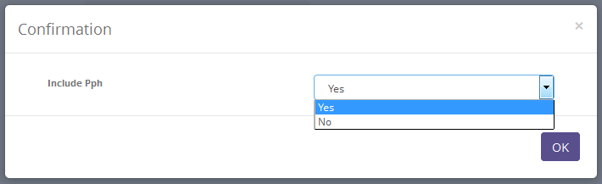

Screen 17: Invoice Pph Confirmation Pop up Dialog

After choosing Yes or No in Pph confirmation screen, system will display Invoice Creation confirmation screen as follows:

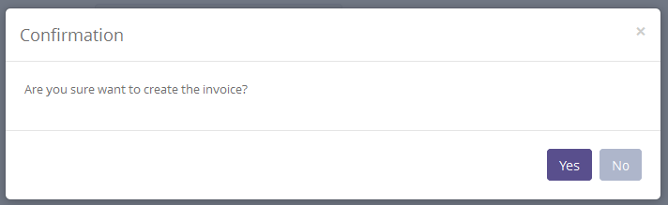

Screen 18: Invoice Confirmation Pop up Dialog

Click **yes** to continue. System will notified if it success or failed to save.



Screen 19: Invoice Creation Success Notification

System will automatically send email to customer and print invoice receipt containing:

* Installment invoice
* Installment receipt
* Maintenance invoice
* Maintenance receipt
* Receive letter

## Create Promise to Pay

After user have sent the invoice or remind customer for payment, user can input the postponed payment date in system by using feature **Promise to Pay**. Please follow procedures shown below:

* 1. Navigate to Monitor Billing Schedule screen, find tab 7 days/5 days/1 day/all.
  2. Click input **Promise to Pay** button on selected agreement.

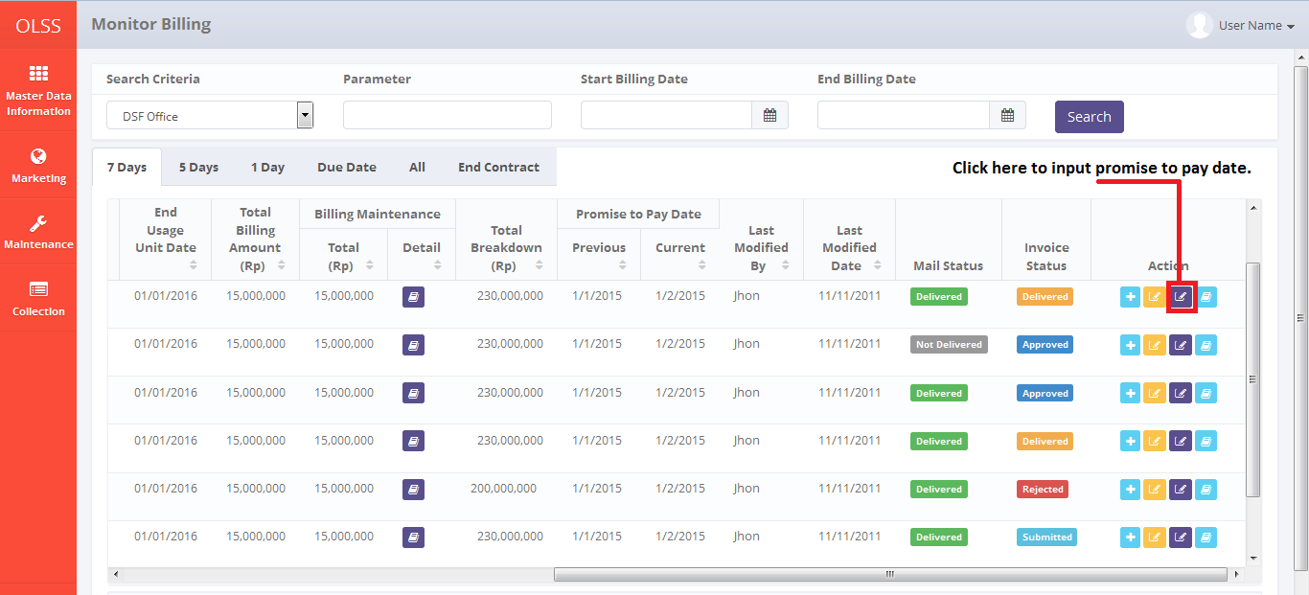

Screen 20: Monitor Billing Schedule Screen – Promise to Pay button

* 1. System will display **Promise to Pay** pop up screen.

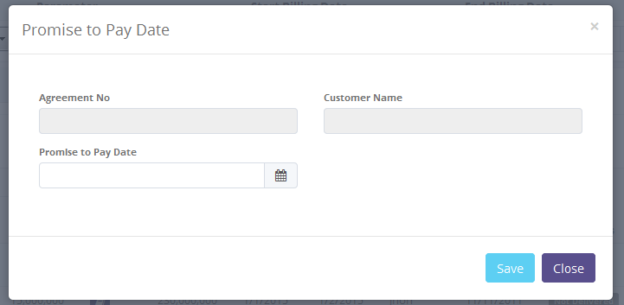

Screen 21: Promise to Pay Pop Up Screen

Once **Promise to Pay** screens pop up, there are 2 buttons displayed:

1. : click the button to save promise payment date.
2. : click to close the pop up screen.

To update **Promise to Pay** date, fill information field as follows:

1. Agreement no: automatically display agreement number.
2. Customer name: automatically display customer name.
3. Promise to pay date: select Promise to pay date.

User can save data on the system by clicking Save. System will automatically go back to **Monitor Schedule** screen. Success notification will show on top of the screen.



Screen 22: Promise to Pay Success Notification

## Billing and Payment Invoice Approval Path

**Billing and payment invoice approval path** holds information for contract information, billing and payment history, and invoice list. In invoice list, there are listed each invoice amount and maintenance invoice on monthly basis. To view **Billing and Payment Invoice Approval path**, click **Billing and Payment Invoice** button on **Monitoring Billing Schedule** screen. System will display **Billing & Payment Invoice Approval Path** screen.

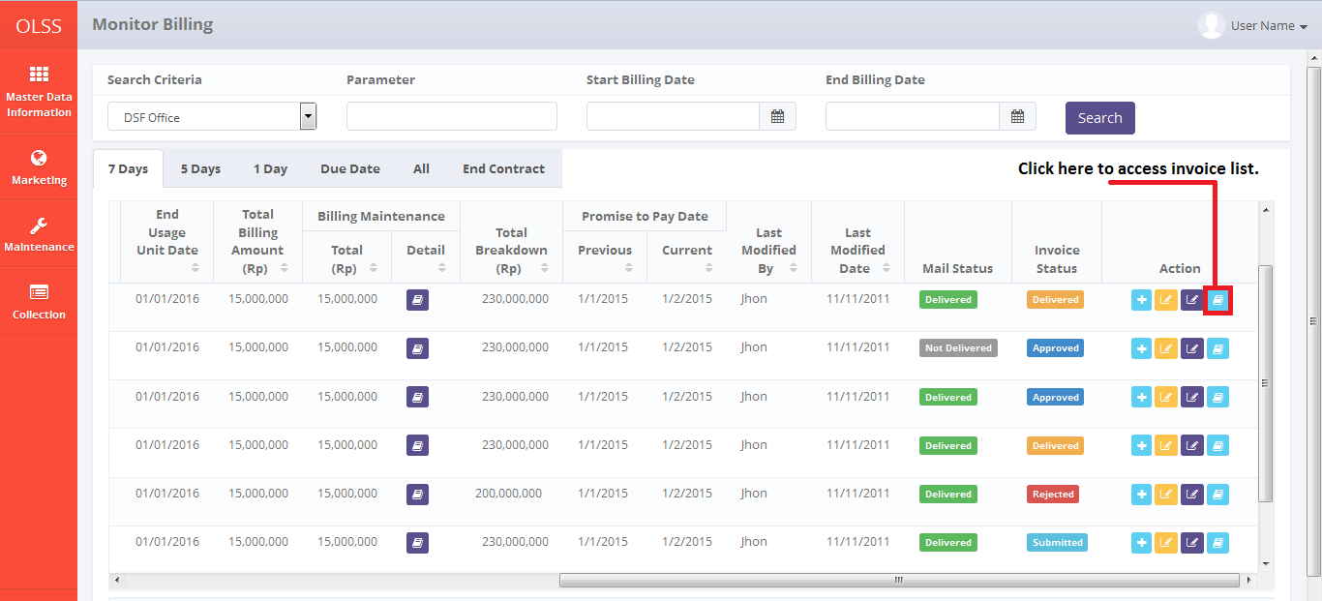

Screen 23: Monitor Billing Schedule screen – Billing and Payment Invoice Approval Path

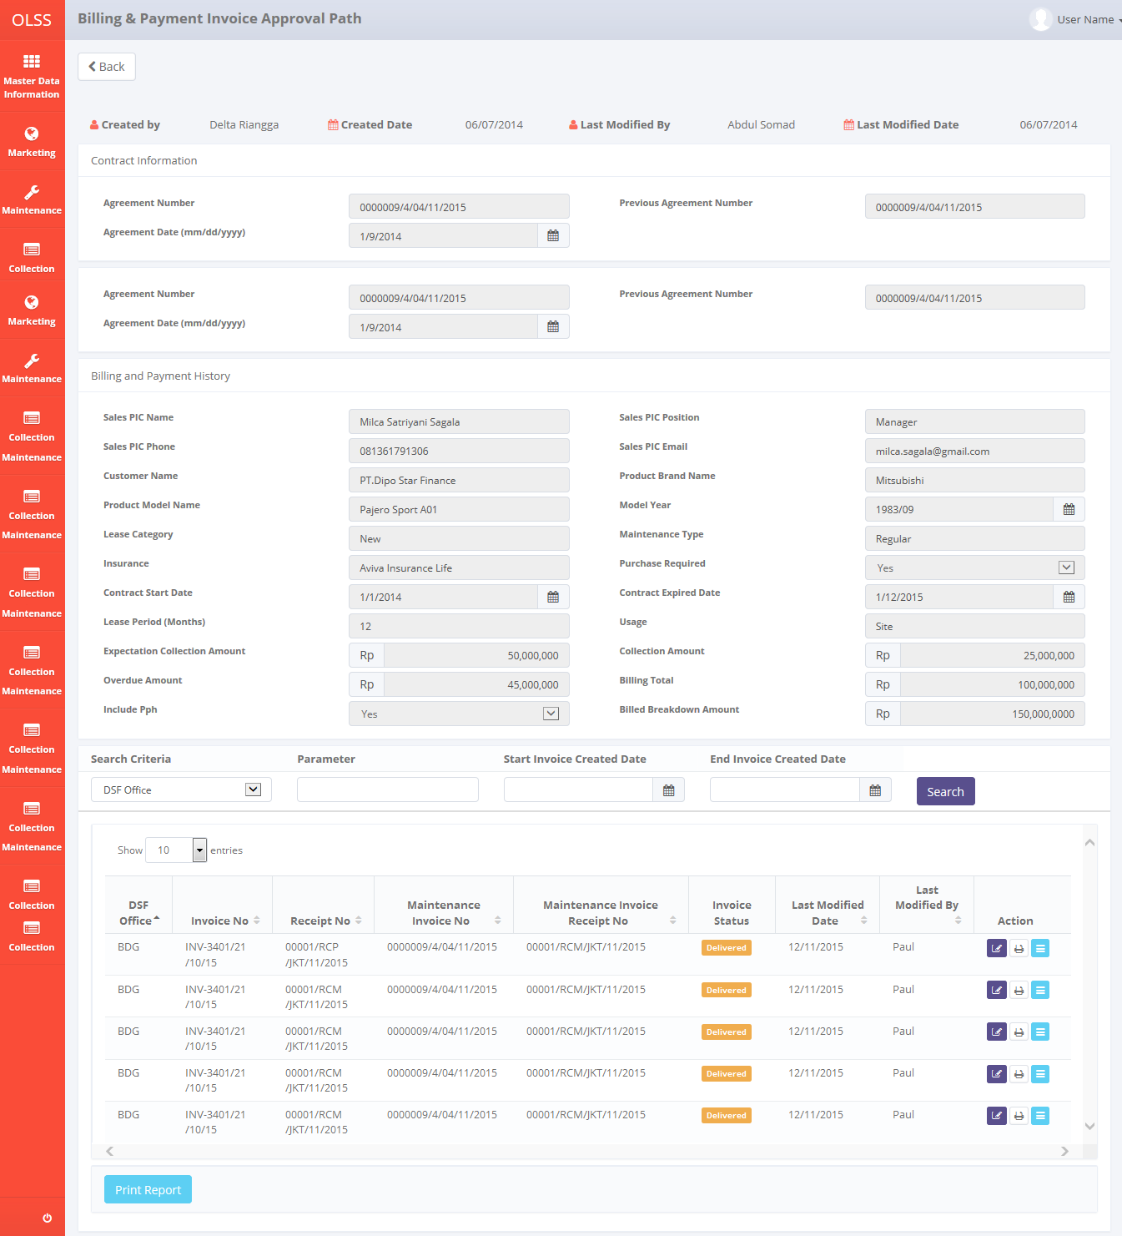

Screen 24: Billing and Payment Invoice Approval Path Screen

There are 5 buttons displayed, which are:

1. : To go to previous screen; which is Monitor Billing Schedule screen.
2. Delivery Invoice Document: input invoice delivery date information.
3. Print: Print invoice form for selected invoice.
4. Invoice Approval: navigate to Invoice Status approval.
5. : print invoice list report.

### Delivery Invoice Document

User can use this feature to input information about invoice delivery. Click the button to access Delivery Invoice Document.

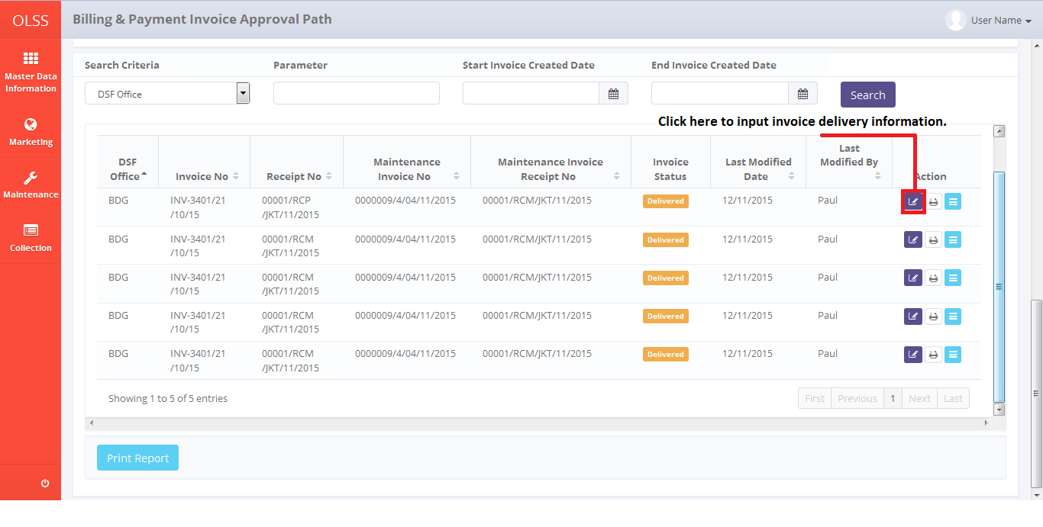

Screen 25 : Billing and Payment Invoice Approval Path Screen – Invoice Delivery Button

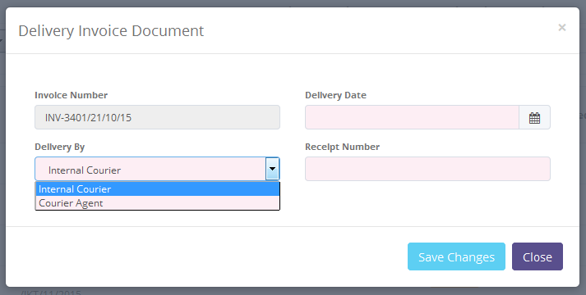

Screen 26: Delivery Invoice Document Pop Up Screen

Then fill the mandatory fields. If the **delivery type** is by Courier Agent, user has to input **Receipt Number**. Click  or  button to go back to **Billing and Payment Invoice Approval Path** screen. Success notification will show on top of the screen. Then invoice status will change to .



Screen 27: Delivery Invoice Success Notification

### Invoice Approval

DSF authorized user can use this feature to check, revise, reject, or approve the invoice before the invoice hardcopy is sent to customer. Invoice approval path is static from PIC collection – HOB/HOD – RM – Director – President Director. First, access the screen by clicking Invoice Status button.

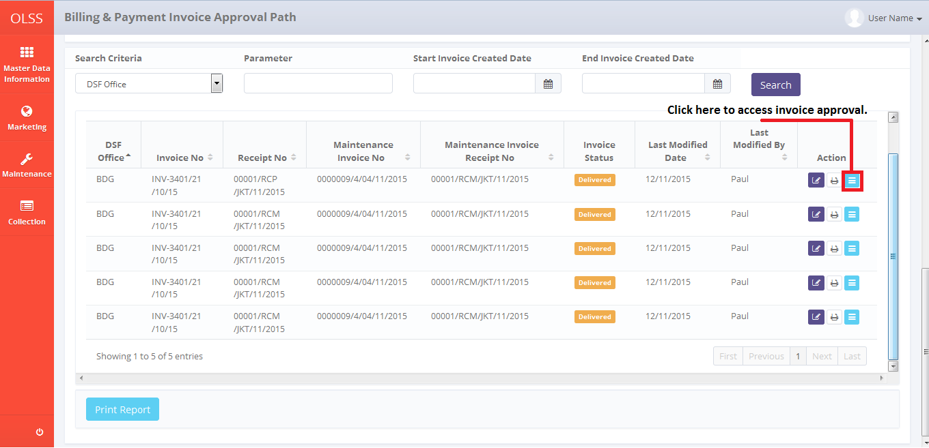

Screen 28: Billing and Payment Invoice Approval Path – Invoice Approval Button

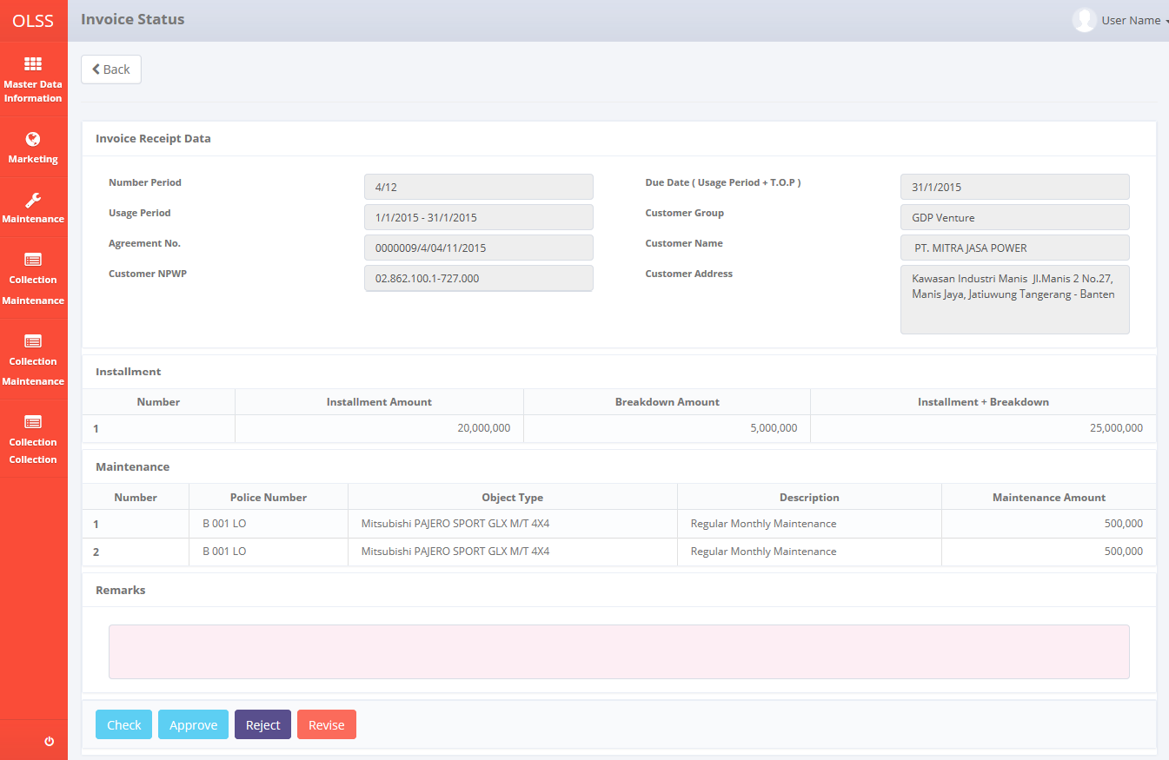

Screen 29: Invoice Approval Screen

Input remarks with reason, and then click check, revise, reject, or approve the invoice. Screen will change back to **Billing and Payment Invoice Approval Path** screen and invoice status will change according the button clicked. After the invoice is approved, the invoice can be sent to customer.

### Print Invoice Form

To print Invoice form, user can access the feature from Billing and Payment Invoice Approval Path screen, and then click on Print button on selected invoice.

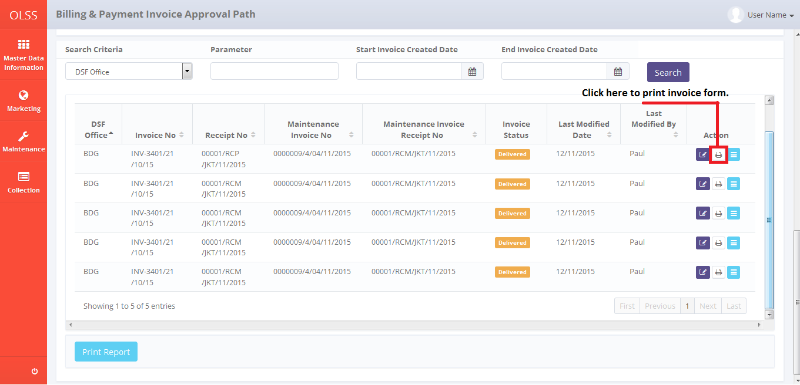

Screen 30: Billing and Payment approval path – print button

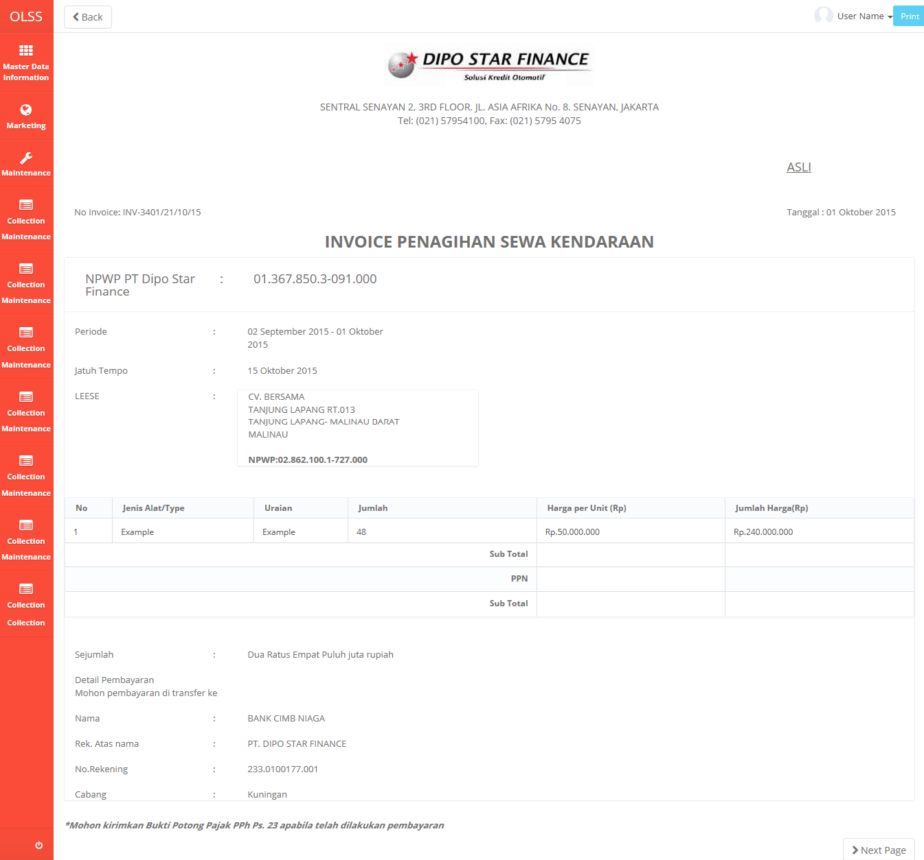

Screen 31: Billing and Payment form print preview

User can choose to print the Invoice form, or save document as Excel or PDF. After printing or saving the document, system will automatically go back to Billing and Payment Invoice Approval Path screen and success notification will show on top of the screen.

Screenshot

### Print List of Invoice Report

To print Invoice List report, user can access the feature from **Billing and Payment Invoice Approval Path** screen, click on Print Report button on the bottom of the screen.

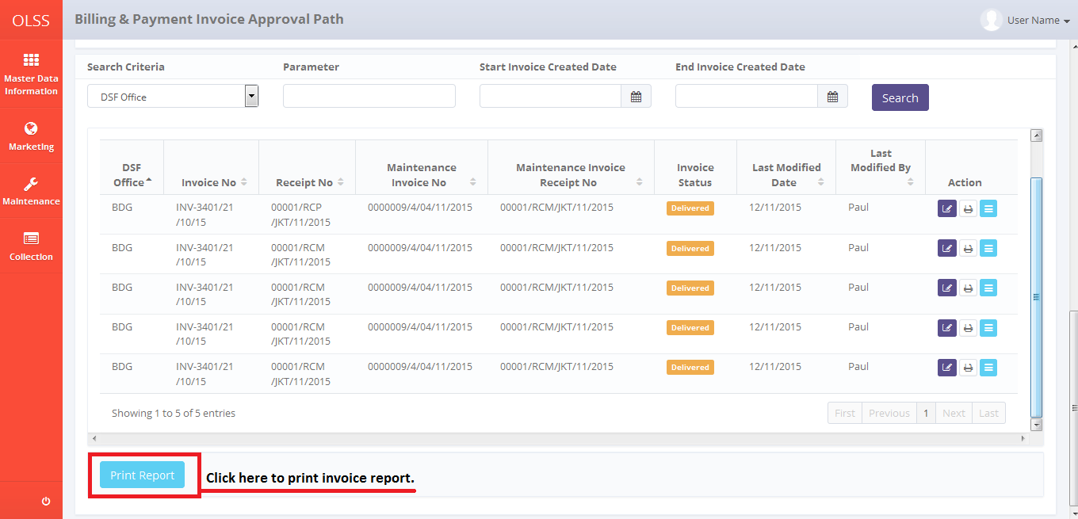

Screen 32: Billing and Payment Invoice Approval Path Screen - Print Report Button

**Screenshot for print preview**

User can choose to print the List of Invoice Report, or save document as Excel or PDF. After printing or saving the document, system will automatically go back to previous screen and success notification will show on top of the screen.

Screenshot

## View Billing and Payment History Inquiry

This feature will give user a view for contract information, billing and payment history, insert new partial payment, and edit billing and payment. To use this feature, simply navigate to tab 5 days or tab 1 day. Then click **Billing and Payment History Inquiry** button.

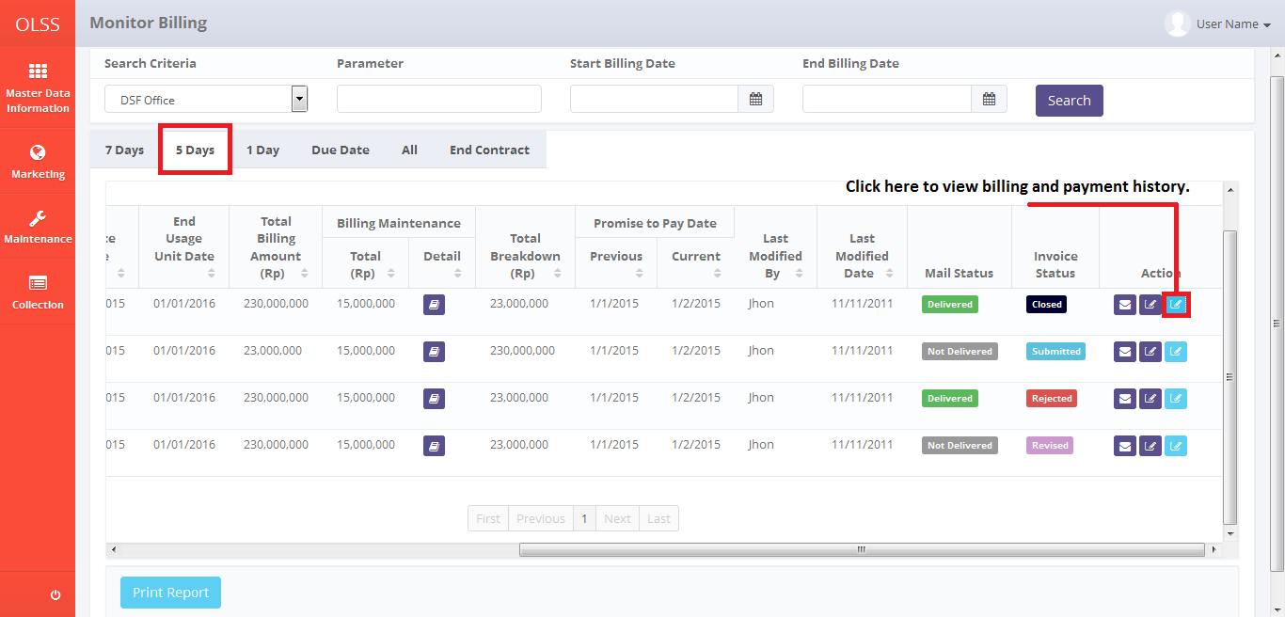

Screen 33: Monitor Billing Schedule Screen – Tab 5 Days

System will navigate to Billing and Payment History Inquiry screen.

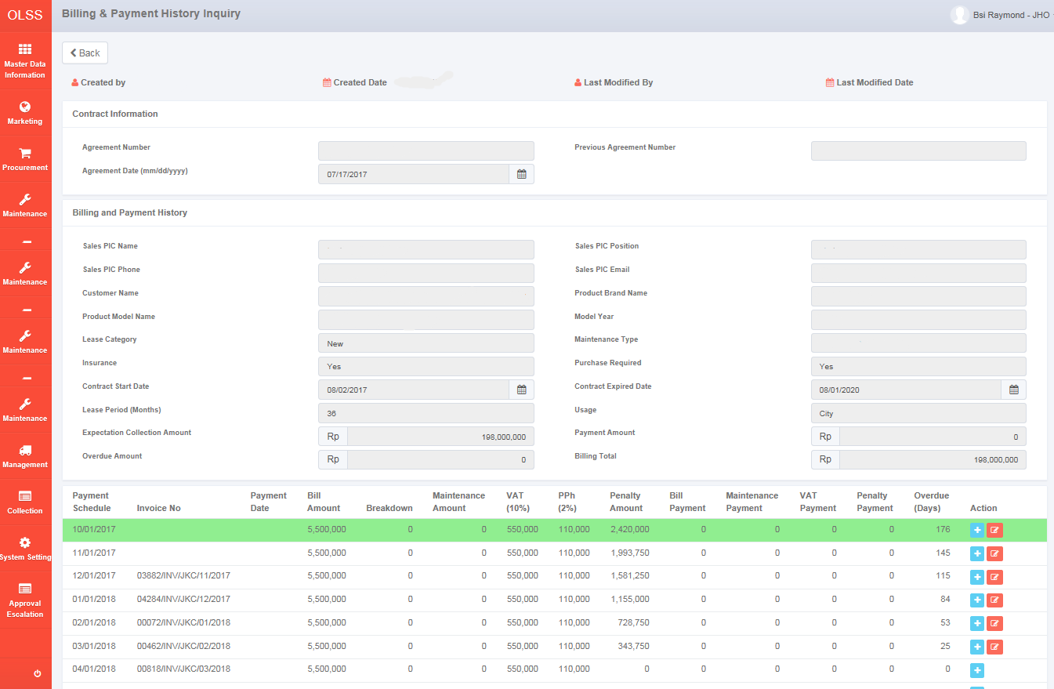

Screen 34: Billing and Payment History Inquiry Screen

There are total 3 buttons displayed.

* 1. : To go back to previous screen; Monitor Billing Schedule screen.
  2. Billing and payment history detail: currently inactive because of synchronization feature (was used to input payment)
  3. Edit Invoice Receipt : To input invoice receipt that was missed during the period.

There are payment schedule on the bottom of the screen. Each row is generated each month. Any kind of payment that happens within the Billing Schedule came from MFAPPL (synchronized) and will update the screen.

## Create RAL

Return Authorization Letter is made after the customer contract had ended. To create RAL, there are two ways, first navigate to Monitor Billing Schedule screen – Tab End Contract. Click **Create RAL** button on the selected agreement.

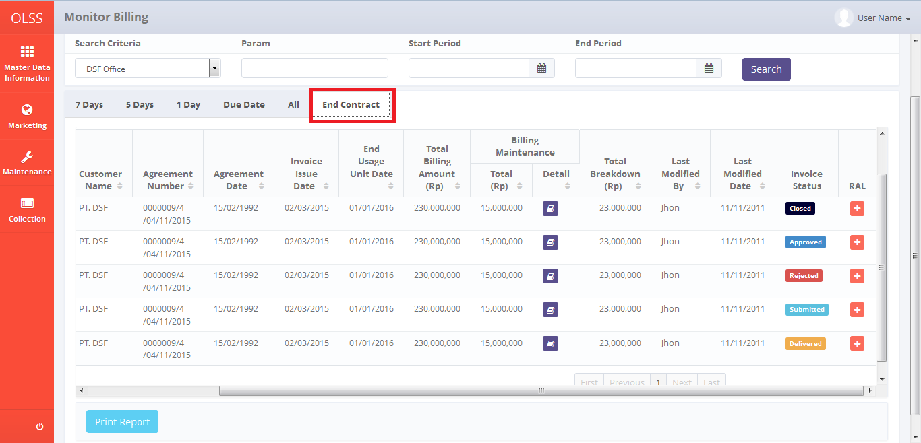

Screen 35: Monitor Billing Schedule – End Contract Tab

Or navigate to Monitor Billing Overdue, and click Create RAL button.

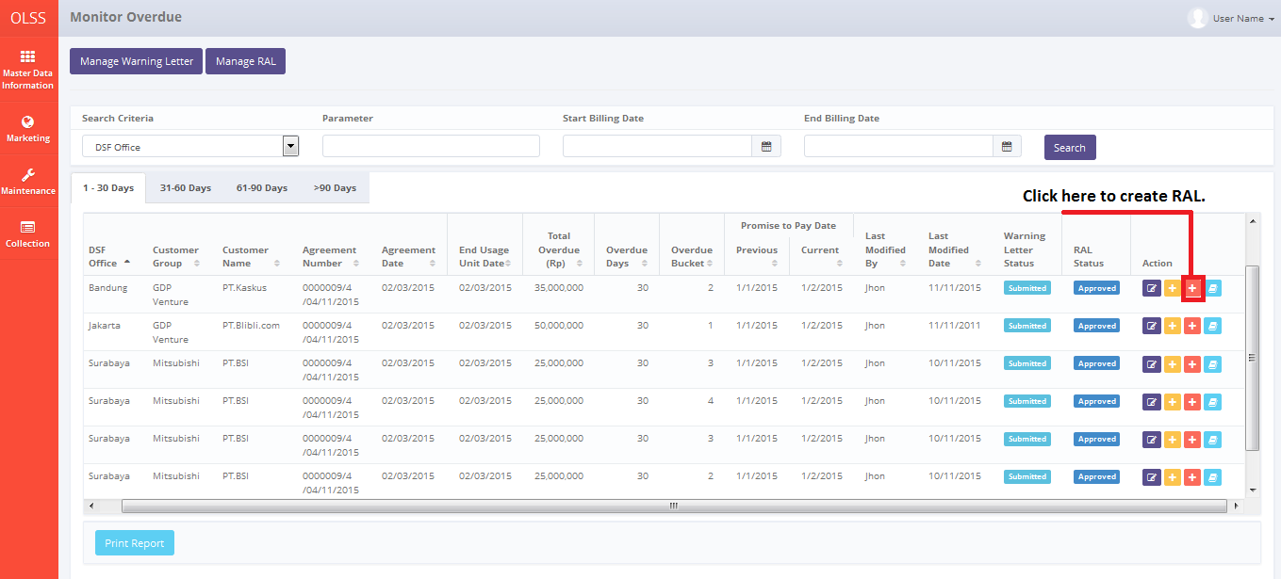

Screen 36: Monitor Overdue Screen – RAL button

System will display **Create RAL** screen.

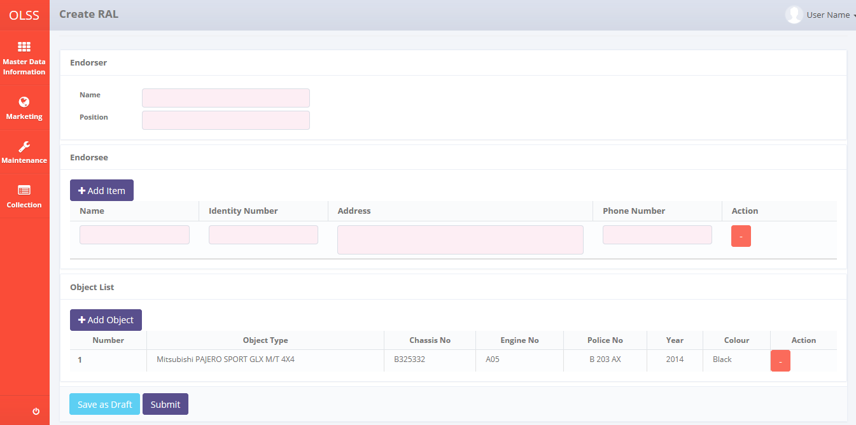

Screen 37: Create RAL Screen

Fill information on the fields as follow:

1. Endorser

* Name: input endorser name.
* Position: input endorser work position.

1. Endorsee

* Name: input endorsee name.
* Identity Number: input endorsee identity number.
* Address: input endorsee address.
* Phone number: input endorsee phone number.
* : click to add more endorsee.

1. Object List

* Click  button to add more unit. System will display Object List pop up screen. Click Object Type to input more units.

User can save data on the system by clicking Save as Draft or Submit. Saved RAL can be managed in Monitor Overdue Screen. Saving RAL as draft will change RAL status into Draft, and submit RAL will change RAL status into Submitted. Clicking Save or Submit button will display confirmation pop-up dialog will show up. Click yes to continue. System will automatically go back to **Monitor Schedule** screen and success notification will show on top of the screen.



Screen 38: Create RAL Success Notification

# Monitor Billing Overdue

Monitor Billing Overdue screen featured monitoring overdue agreement, manage RAL, and manage warning letter. Overdue means agreement current date is more than agreement due date, and also customer hasn’t conduct payment yet. To get to Monitor Billing Overdue screen, please navigate to Collection Menu, and choose Monitor Billing Overdue.

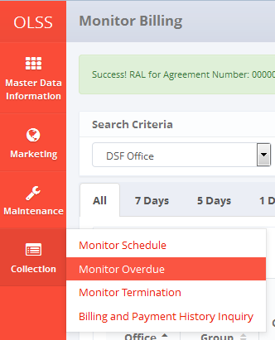

Screen 39: Collection Menu – Monitor Overdue

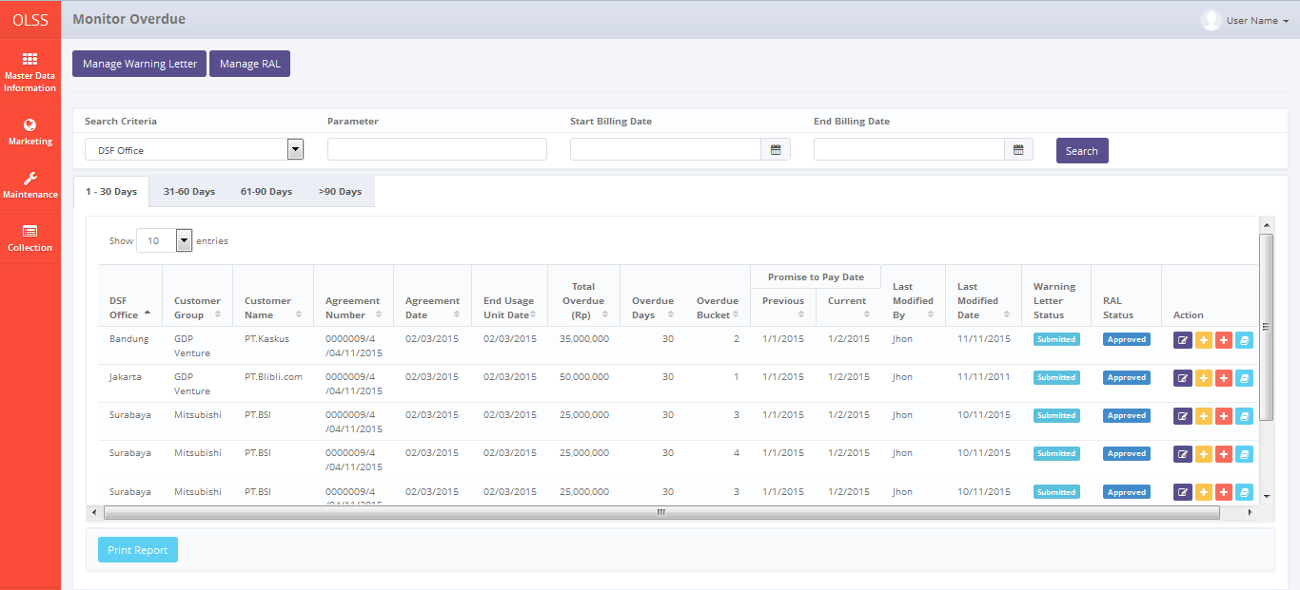

Screen 40: Monitor Billing Overdue Screen

On the screen of Monitor Billing Overdue, there are 4 tabs:

1. 1-30 days: display billing data with overdue from 1 – 30 days.
2. 31-60 days: display billing data with overdue from 31 - 60 days.
3. 61-90 days: display billing data with overdue from 61 – 90 days.
4. > 90 days: display billing data with overdue more than 90 days.

On the screen of Monitor Billing Overdue, there are 7 buttons:

1. : monitor warning letter document.
2. : monitor RAL document.
3. Reminder Memo: Update reminder information for selected agreement.
4. Create warning letter: create warning letter for selected agreement.
5. Create RAL: create RAL for selected agreement.
6. Reminder memo history: view reminder memo history for selected agreement.
7. : Print Overdue billing list for specific search.

## Create Reminder Memo

User can input update after reminding customer for monthly payment by utilizing **Reminder Memo** feature. If user wants to use function **Reminder Memo**, please follow procedures shown below:

1. Click **Reminder Memo** button on selected agreement (first button on the action column) on **Monitor Billing Overdue** screen.

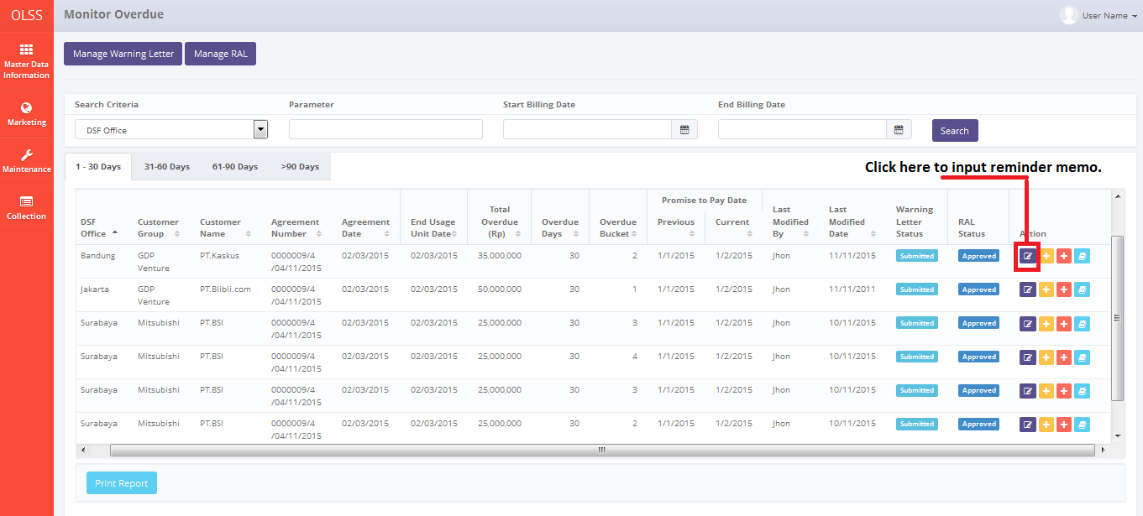

Screen 41: Monitor Billing Overdue – Reminder Memo Button

1. System will display Reminder Memo pop up screen.

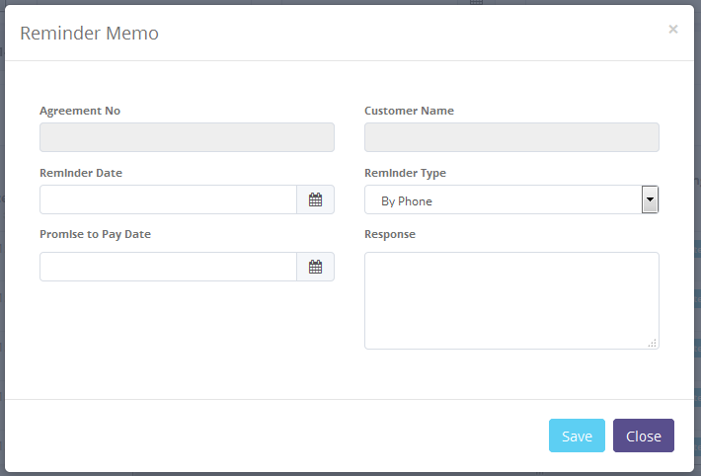

Screen 42: Reminder Memo Screen

Fill fields with necessary information as follows:

* Agreement No: automatically display selected agreement number.
* Customer Name: automatically display selected customer name.
* Reminder Date: input reminder date.
* Reminder Type: input type By Phone or By Visit.
* Response: input customer response.

User can save data on the system by clicking Save. Any new information will be recorded in **Reminder Memo History**. Clicking Save button will display confirmation pop-up dialog will show up. Click yes to continue. System will automatically go back to **Monitor Billing Overdue** screen.

## Create Warning Letter

If the agreement has reached past the due date and customer hasn’t conducted the payment, then user can create Warning Letter for selected agreement. To create Warning Letter, click Create Warning Letter button on the selected agreement.

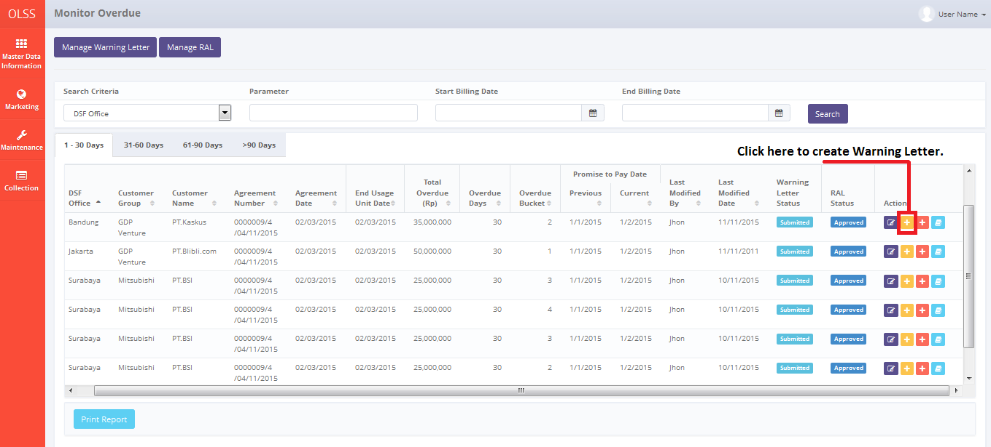

Screen 43: Monitor Billing Overdue – Warning Letter Button

System will display Create Warning Letter screen.

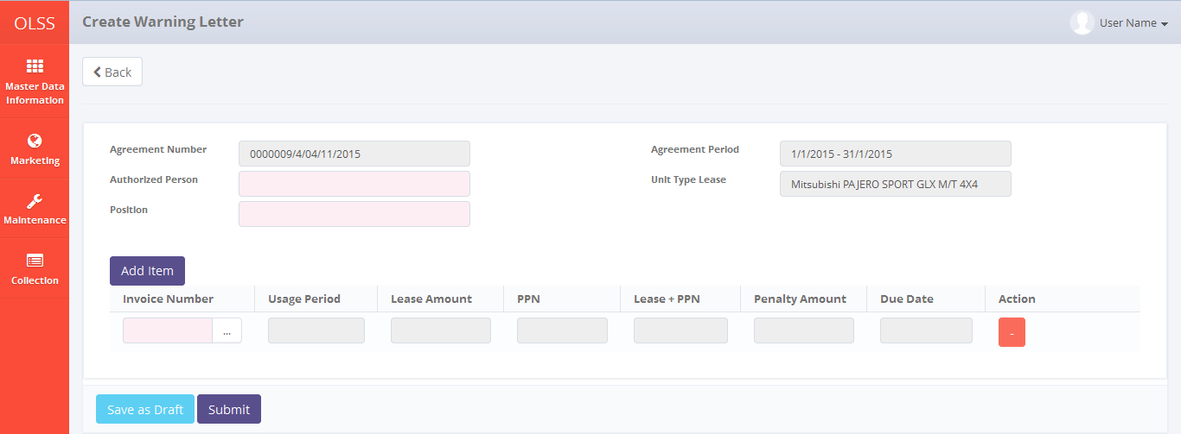

Screen 44: Create Warning Letter Screen

Fill information as follows:

* Authorized Person: input authorized user who make the warning letter.
* Position: input authorized person job position.
* Select Invoice Number to be issued. Click add item button to make Warning Letter for more than one invoice number at once.

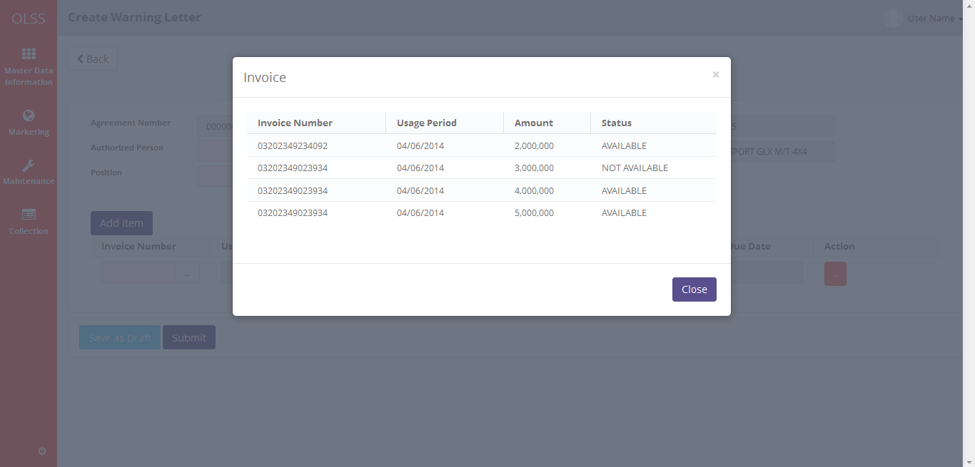

Screen 45: Invoice List in Create Warning Letter Screen

User can save data on the system by clicking Save as Draft or Submit button. Saved Warning Letter can be managed in Monitor Overdue Screen. Saving Warning Letter as draft will change Warning Letter status into Draft, and submit Warning Letter will change Warning Letter status into Submitted. Clicking Save button will display confirmation pop-up dialog will show up. Click yes to continue. System will automatically go back to **Monitor Billing Overdue** screen. System will display success notification on top of the screen.



Screen 46: Warning Letter Success Notification

## Edit Warning Letter

To edit warning letter, user can navigate to List of Warning Letter screen, by clicking Manage Warning Letter button on top of Monitor Overdue screen.

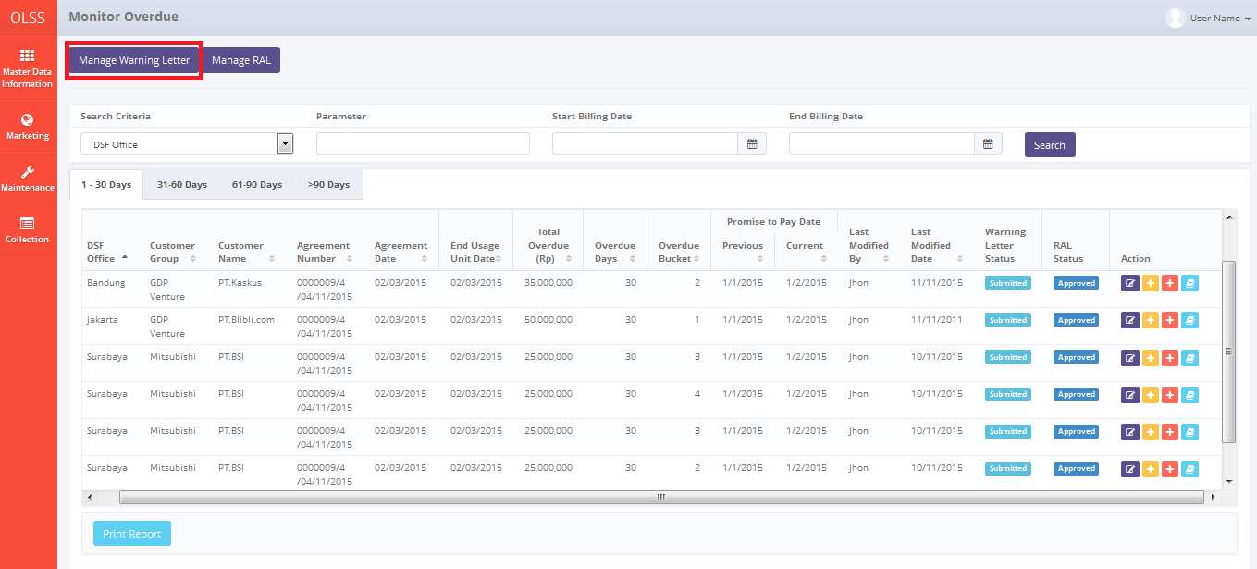

Screen 47: Monitor Billing Overdue – Manage Warning Letter

System will navigate to List of Warning Letter screen. In here user can see warning letter created, overdue bucket and overdue days, total overdue, and warning letter status. Click Edit Warning Letter button on the selected Warning Letter document.

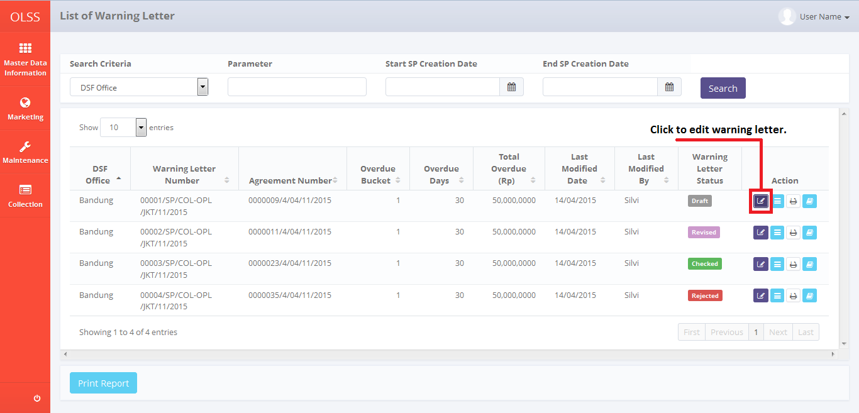

Screen 48: List of Warning Letter – Edit button

System will navigate to Edit Warning Letter screen.

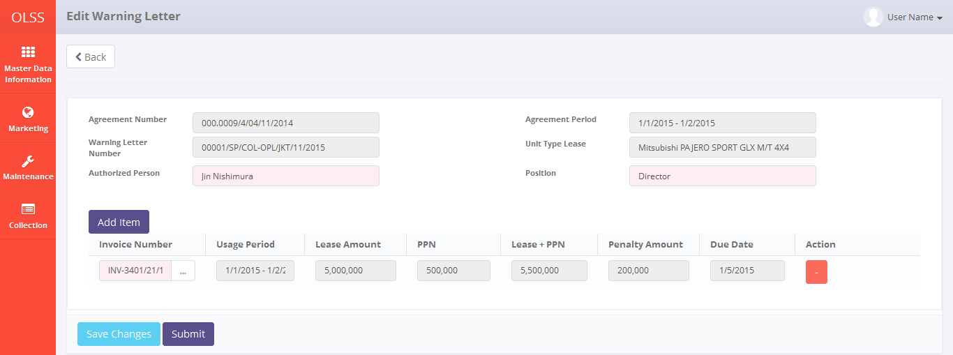

Screen 49: Edit Warning Letter Screen

If data already changed on the screen, user can save a data on the system by clicking **Save Changes** button or Submit. There are mandatory fields marked with red background field that should be inputted and it can’t leave as blanks. If you leave them blanks, system will notified it after you clicking **Save Changes or Submit** button. Make sure that you really want to submit the document, because Submitted document can no longer be modified. After clicking **Save Changes or Submit**, confirmation pop-up dialog will show up. Click yes to save document.

Screenshot

System will notified if it success or failed to save changes.

Screenshot for notification update

## Warning Letter Approval

DSF authorized user can use this feature to check, revise, reject, or approve the warning letter. First, access the screen by clicking Warning Letter approval button.

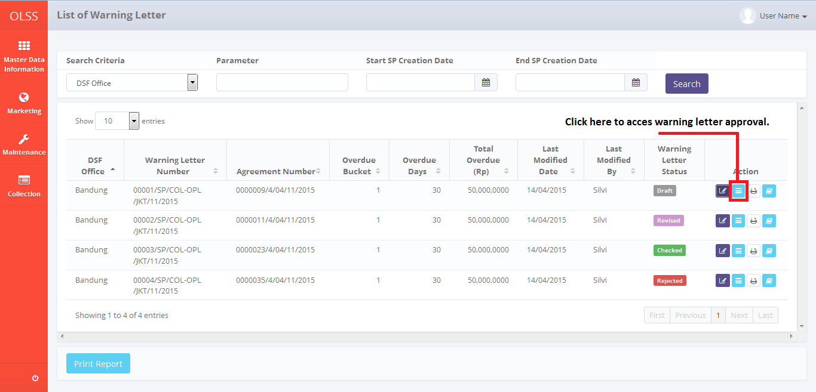

Screen 50: List of Warning Letter – Warning Letter Approval Button

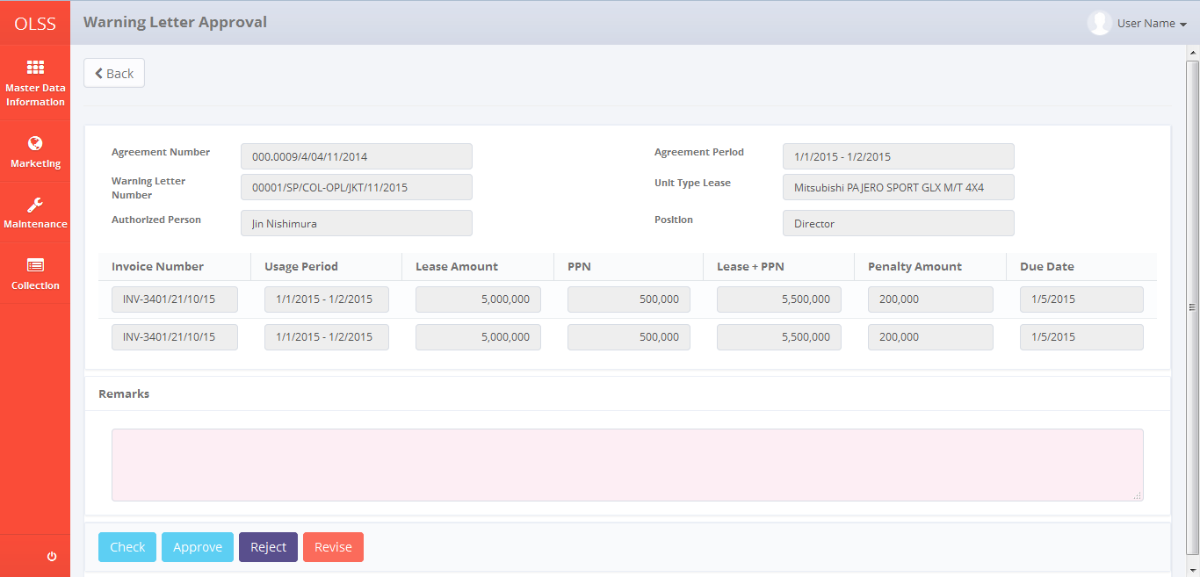

Screen 51: Warning Letter Approval Screen

Input remarks with reason, and then click check, revise, reject, or approve the invoice. Screen will change back to **List of Warning Letter** screen and Warning Letter status will change according the button clicked.

## Print Warning Letter Form

To print Warning Letter form, click Print button on selected Warning Letter.

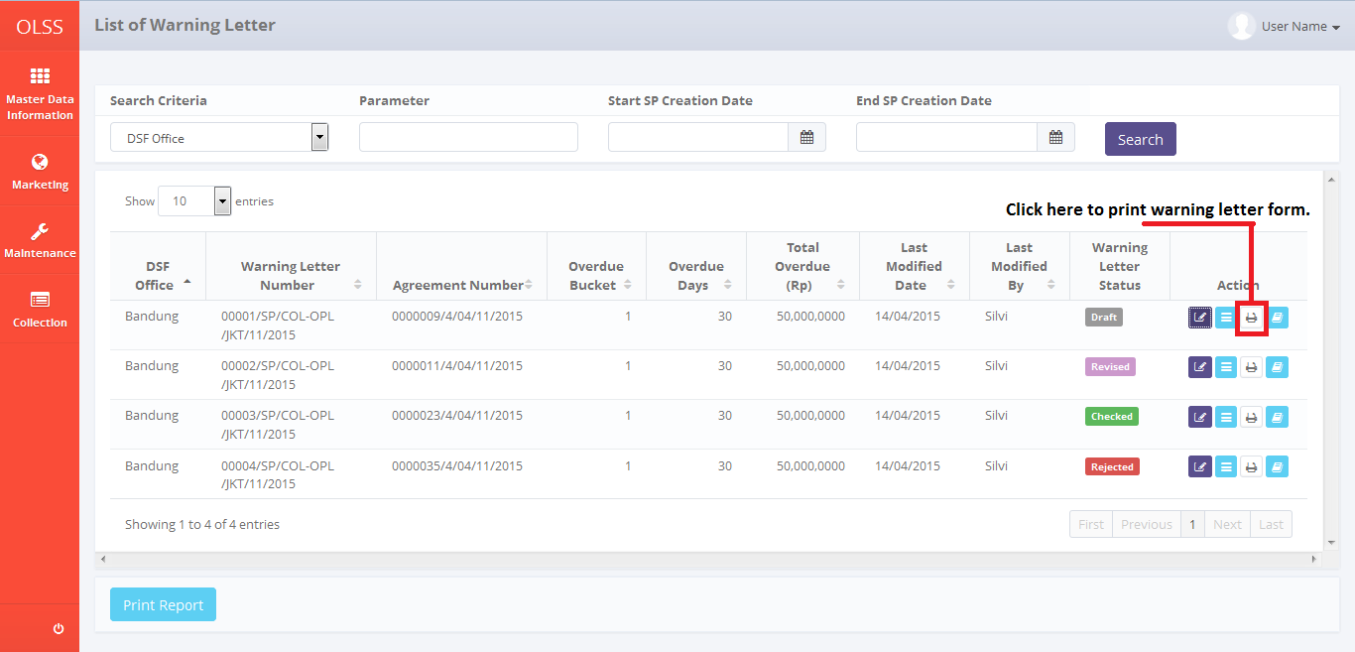

Screen 52: List of Warning Letter – Print Warning Letter Form Button

System will navigate to Warning Letter Form print preview.

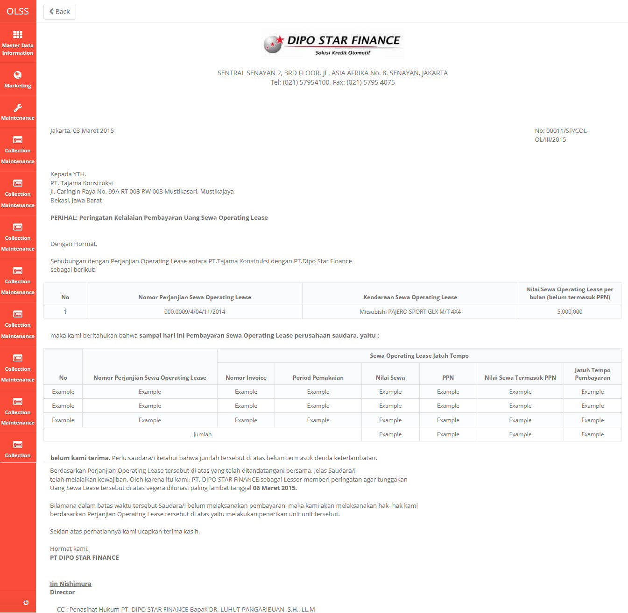

Screen 53: Warning Letter Form

User can choose to print the Warning Letter form, or save document as Excel or PDF. After printing or saving the document, system will automatically go back to previous screen and success notification will show on top of the screen.



Screen 54: Print Warning Letter Success Notification

## Warning Letter History

User can check the revision date of warning letter by navigating to Warning Letter history. Click Warning Letter History button on the selected Warning Letter number.

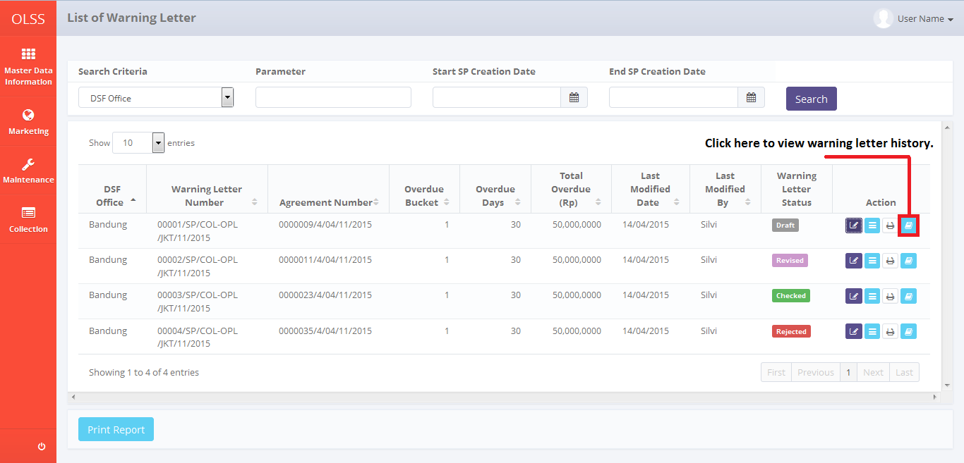

Screen 55: Warning Letter History Button

System will navigate to Warning Letter History screen.

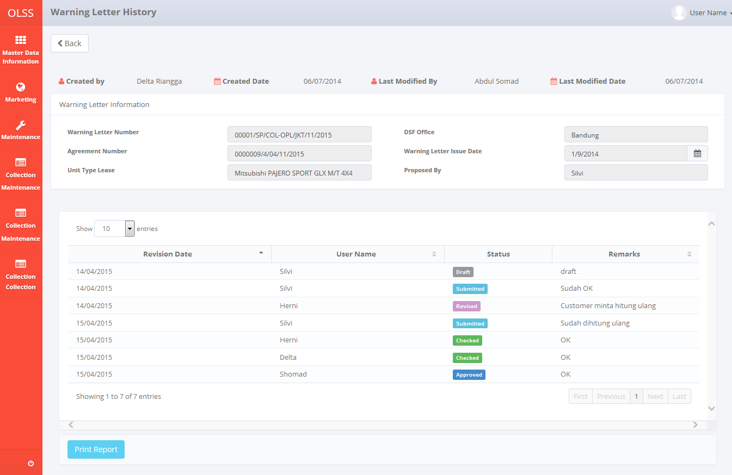

Screen 56: Warning Letter History Screen

## Print Warning Letter Report

To print warning letter report, user can access the feature from Warning Letter History screen, or from List of Warning Letter.

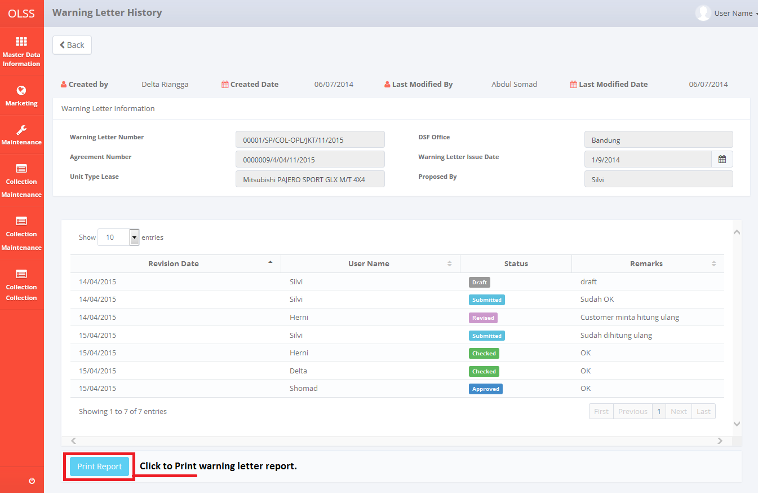

Screen 57: Alternative for Print Warning Letter History Report

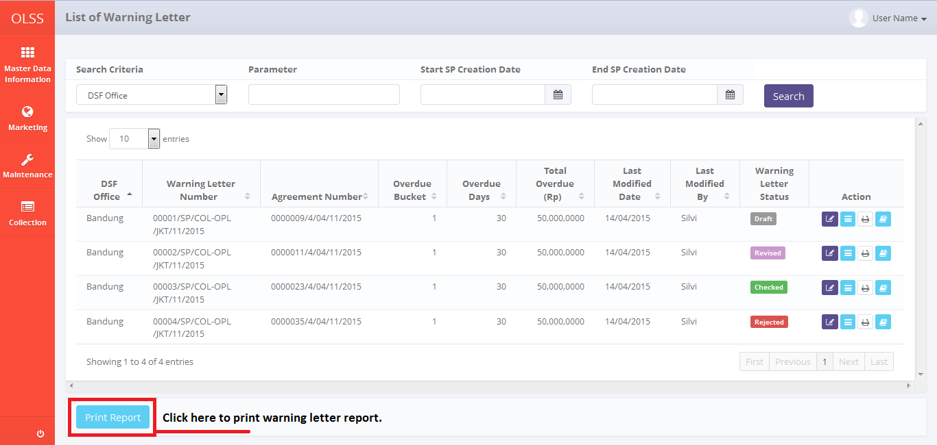

Screen 58: Alternative for Print Warning Letter History Report

User can choose to print the Warning Letter form, or save document as Excel or PDF. After printing or saving the document, system will automatically go back to previous screen and success notification will show on top of the screen.



Screen 59: Print Warning letter report success notification

## Edit RAL

To edit RAL, user can navigate to List of RAL screen, by clicking Manage RAL button on top of Monitor Overdue screen.

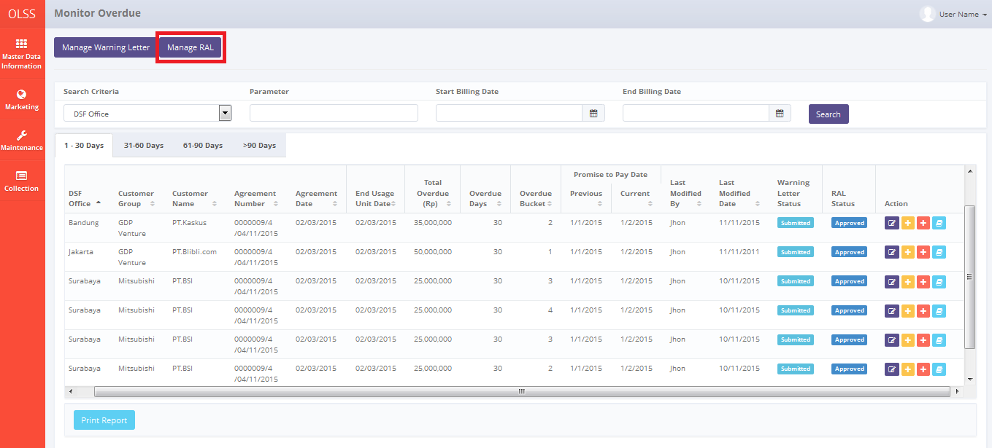

Screen 60: monitor overdue billing – manage RAL button

System will navigate to List of RAL screen. In here user can see RAL created, authorized person information, total unit, and RAL status. Click Edit RAL button on the selected RAL document.

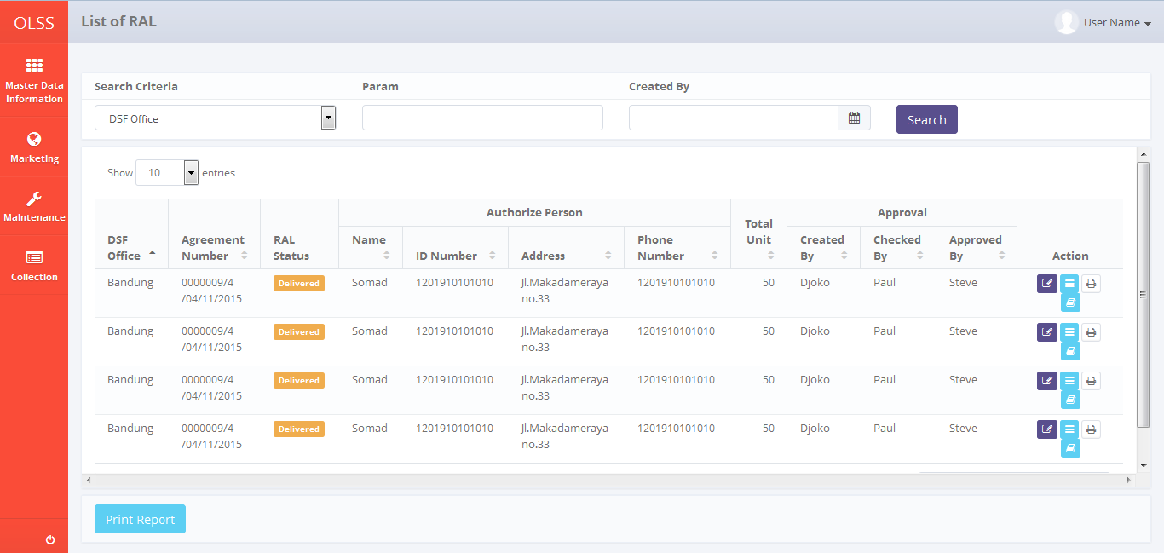

Screen 61: List of RAL screen

System will navigate to Edit RAL screen. On the bottom of the screen, there is a Revision History fields consist of user information that has made changes to the document.

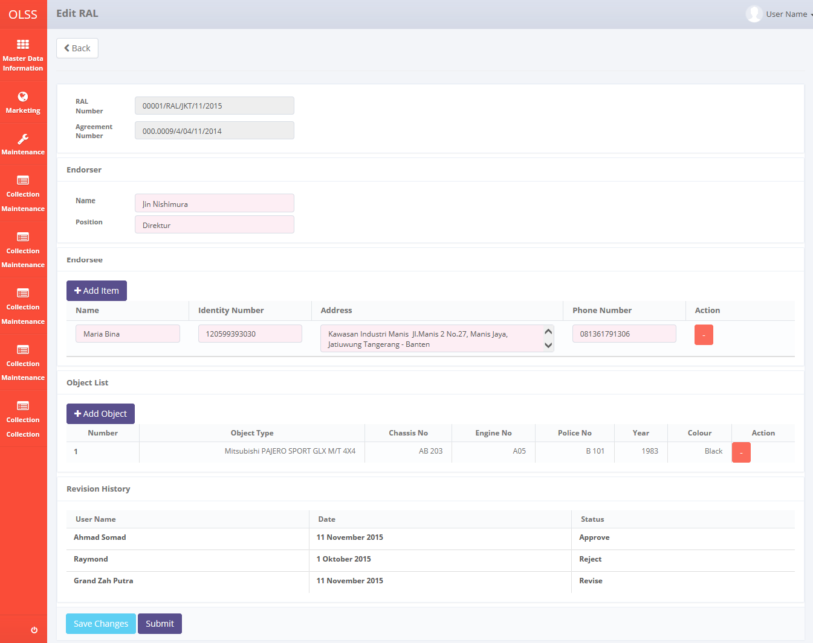

Screen 62: Edit RAL screen

If data already changed on the screen, user can save a data on the system by clicking **Save Changes** button or **Submit**. There are mandatory fields marked with red background field that should be inputted and it can’t leave as blanks. If you leave them blanks, system will notified it after you clicking **Save Changes** or **Submit** button. Make sure that you really want to submit the document, because Submitted document can no longer be modified. After clicking **Save Changes or Submit**, confirmation pop-up dialog will show up. Click yes to save document.

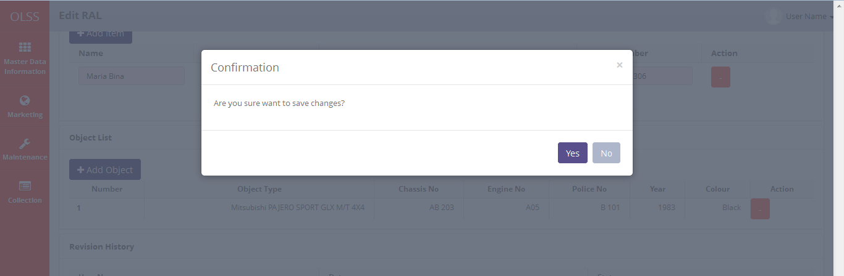

Screen 63: Edit RAL confirmation pop up screen

System will notified if it success or failed to save changes.



Screen 64: Edit RAL Success notification

## RAL Approval

DSF authorized user can use this feature to check, revise, reject, or approve the warning letter. First, access the screen by clicking RAL approval button.

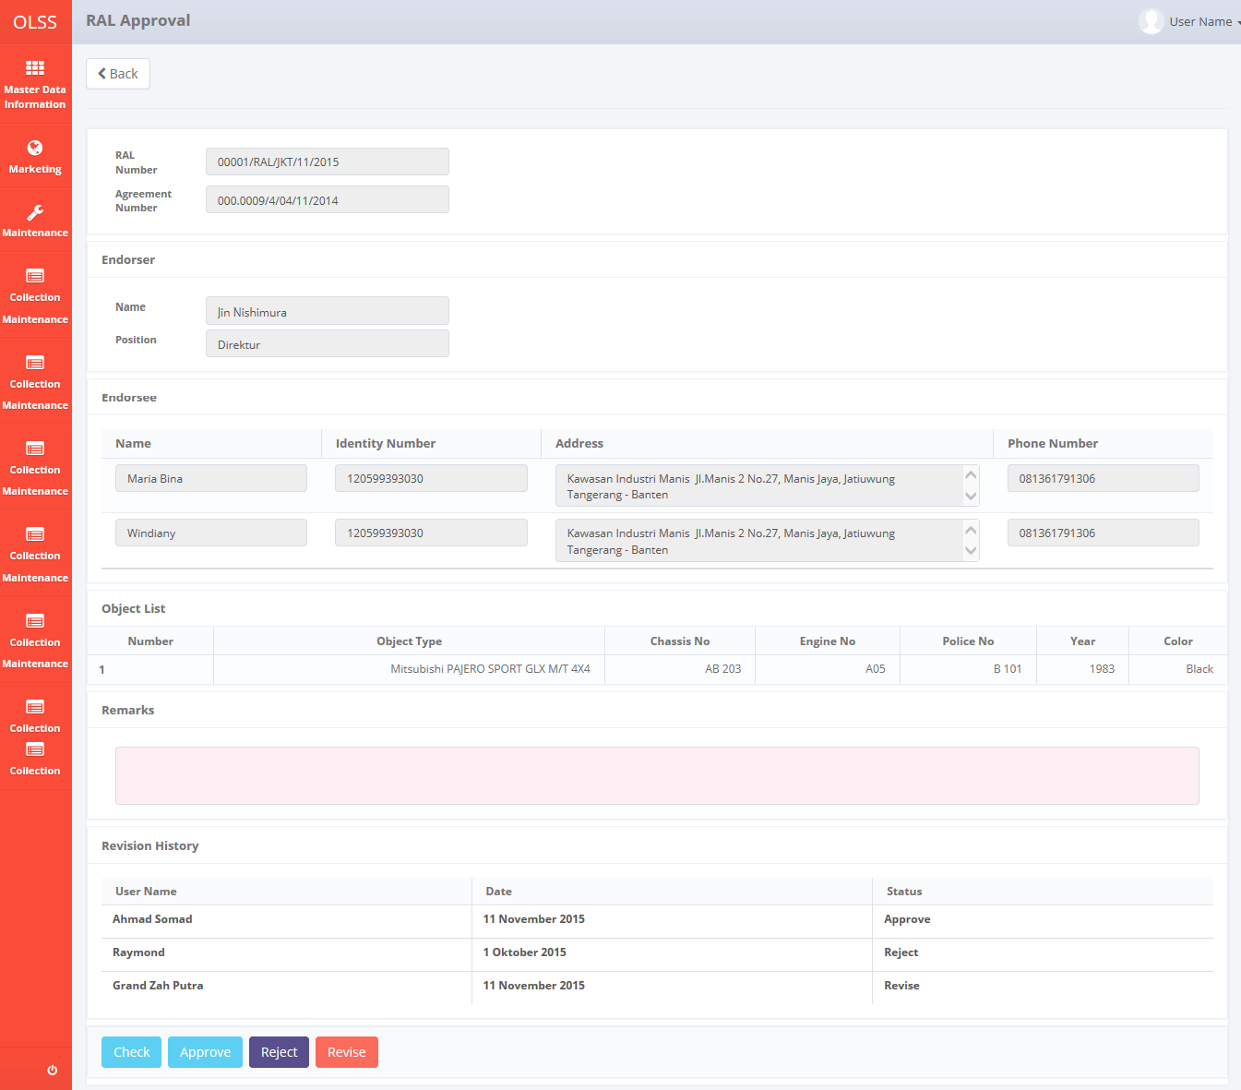

Screen 65: RAL approval screen

Input remarks with reason, and then click check, revise, reject, or approve the RAL. Screen will change back to **List of RAL** screen and RAL status will change according the button clicked.

## Print RAL Form

To print RAL form, click Print button on selected RAL.

Screenshot

System will navigate to RAL Form print preview.

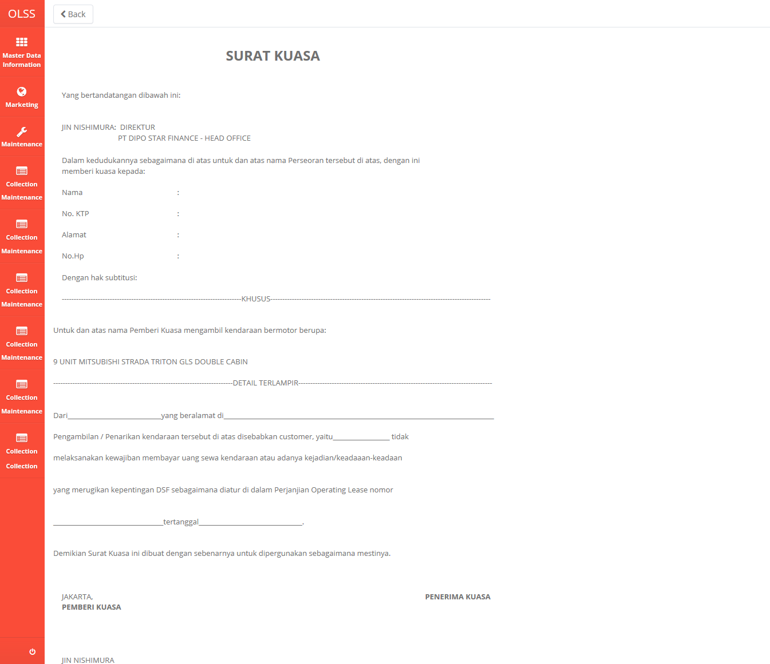

Screen 66: RAL form print preview

User can choose to print the RAL form, or save document as Excel or PDF. After printing or saving the document, system will automatically go back to previous screen and success notification will show on top of the screen.



Screen 67: Print RAL success notification

## RAL History

User can check the revision date of RAL by navigating to RAL history. Click RAL History button on the selected RAL number.

System will navigate to RAL History screen.

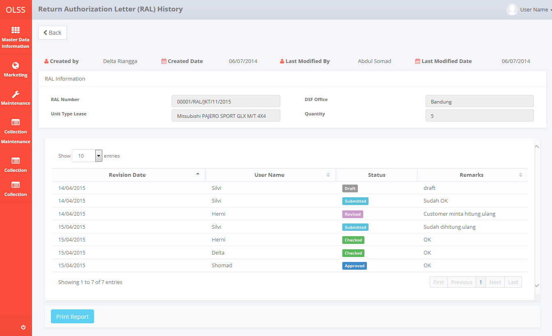

Screen 68: RAL history screen

## Print RAL Report

To print RAL report, user can access the feature from RAL History screen, or from List of RAL.

User can choose to print the RAL form, or save document as Excel or PDF. After printing or saving the document, system will automatically go back to previous screen and success notification will show on top of the screen.

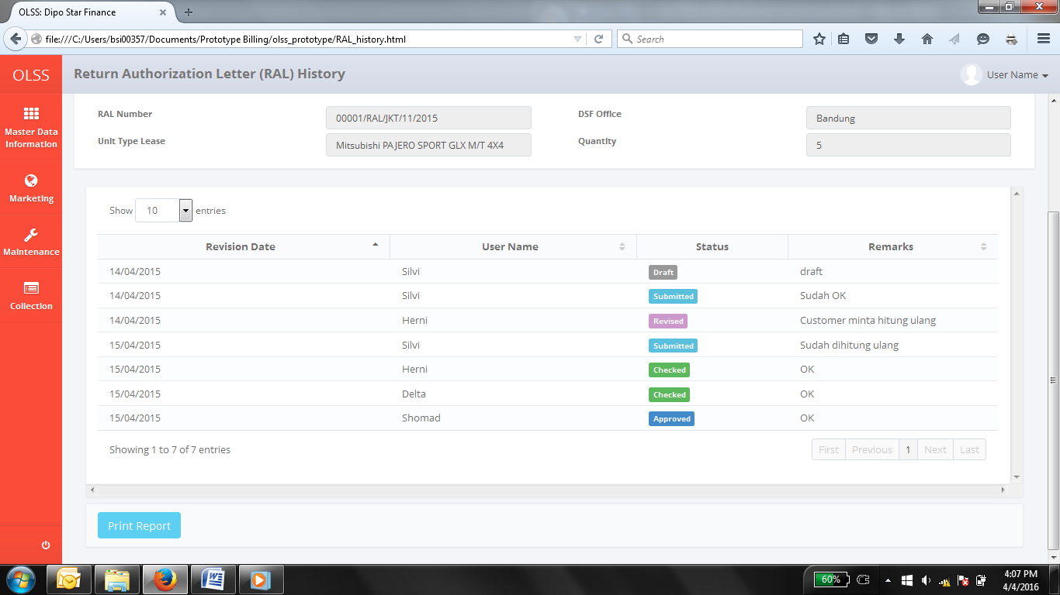

Screen 69: alternative print report via RAL history

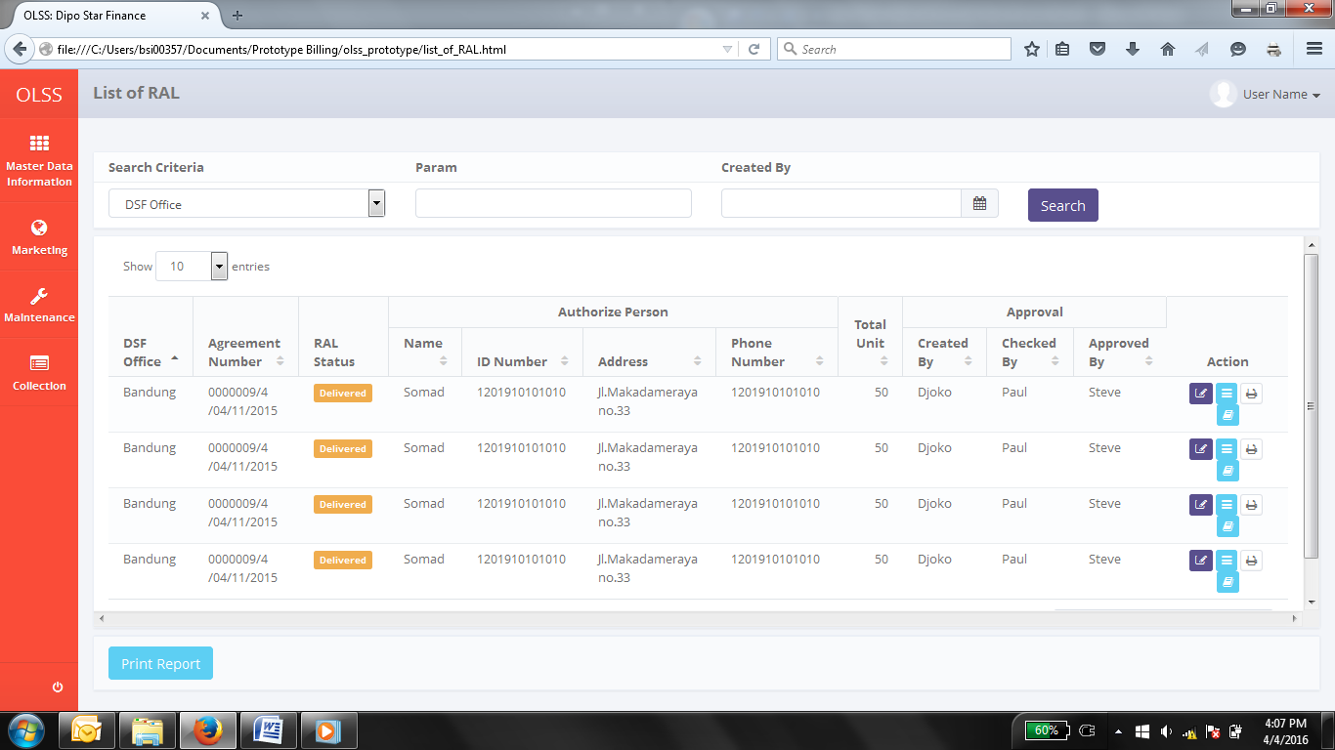

Screen 70: alternative print report via list of RAL screen

## Print Billing (schedule/overdue) History

On the bottom screen of Monitor Billing Schedule and Monitor Billing Overdue screen, there is a button for Print Report. User can use the feature to print the Billing Schedule History report and Monitor Billing Overdue screen.

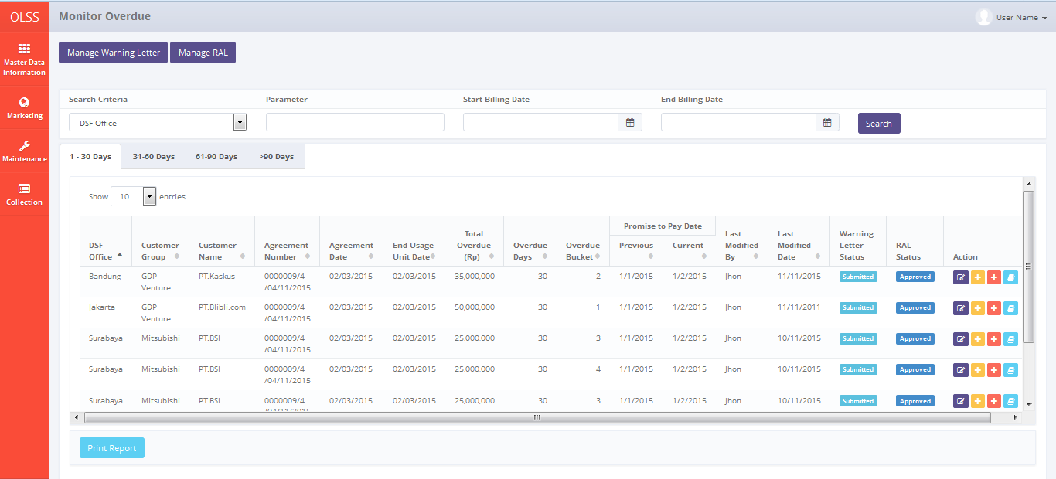

Screen 71: Print report for monitor overdue billing

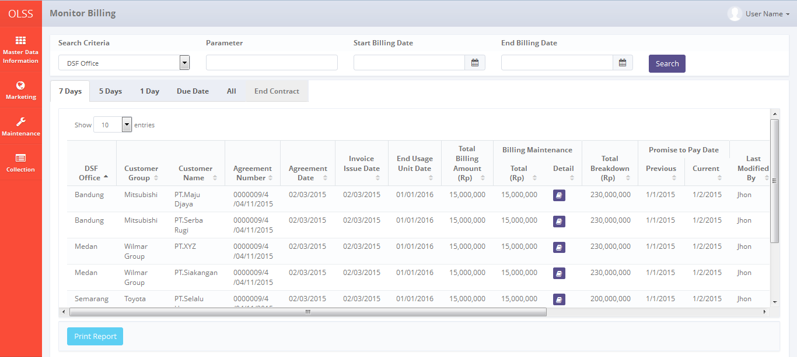

Screen 72: Print report for monitor billing schedule

After clicking the button, system will navigate to Billing report print preview. User can print document as hardcopy, or save document as PDF or Ms. Excel.